**DTR Attendance System Manual for HR**

**Employee Dashboard**

1. **Import Data**
   * **Department**: Upload department data to ensure all departments are accurately represented in the system.
   * **Position**: Upload position data to ensure all job titles are accurately represented in the system.
   * **Employee**: Upload employee data to populate the employee database. 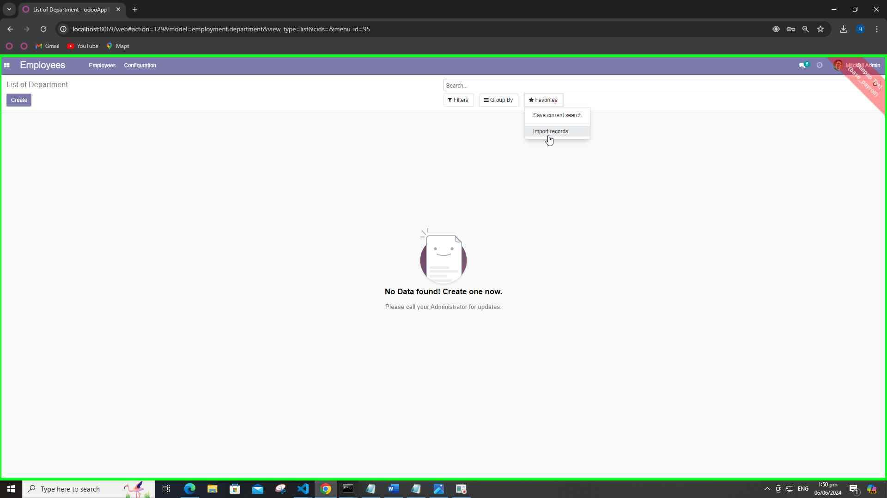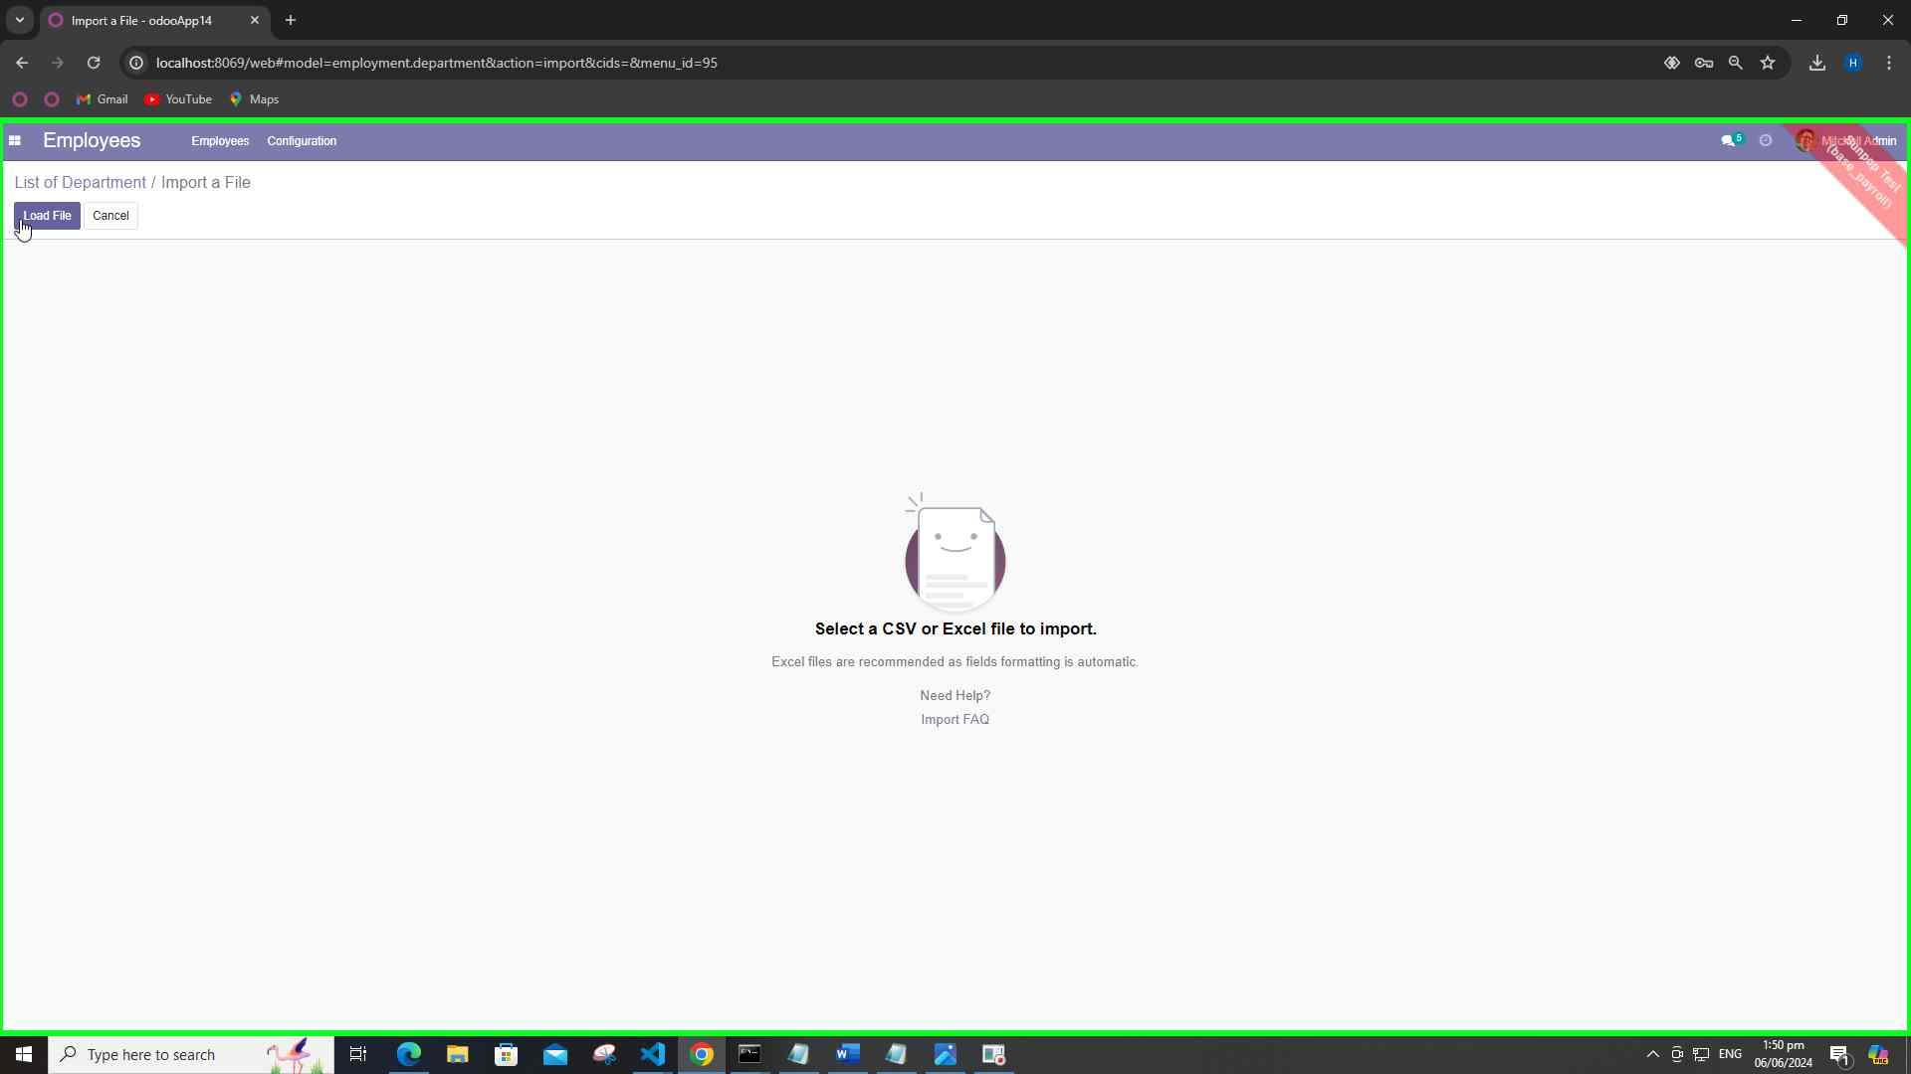

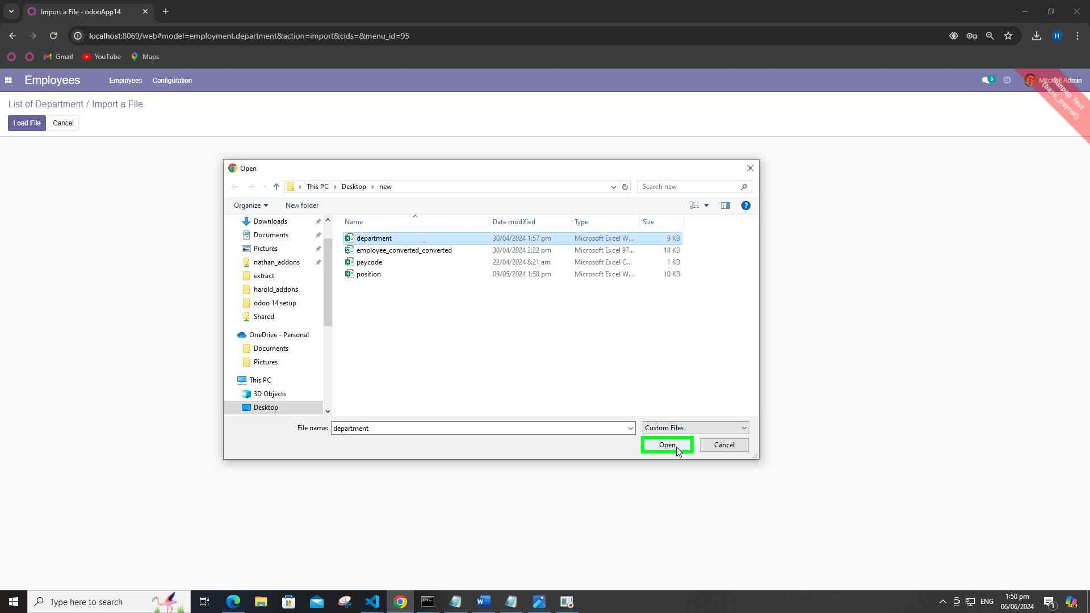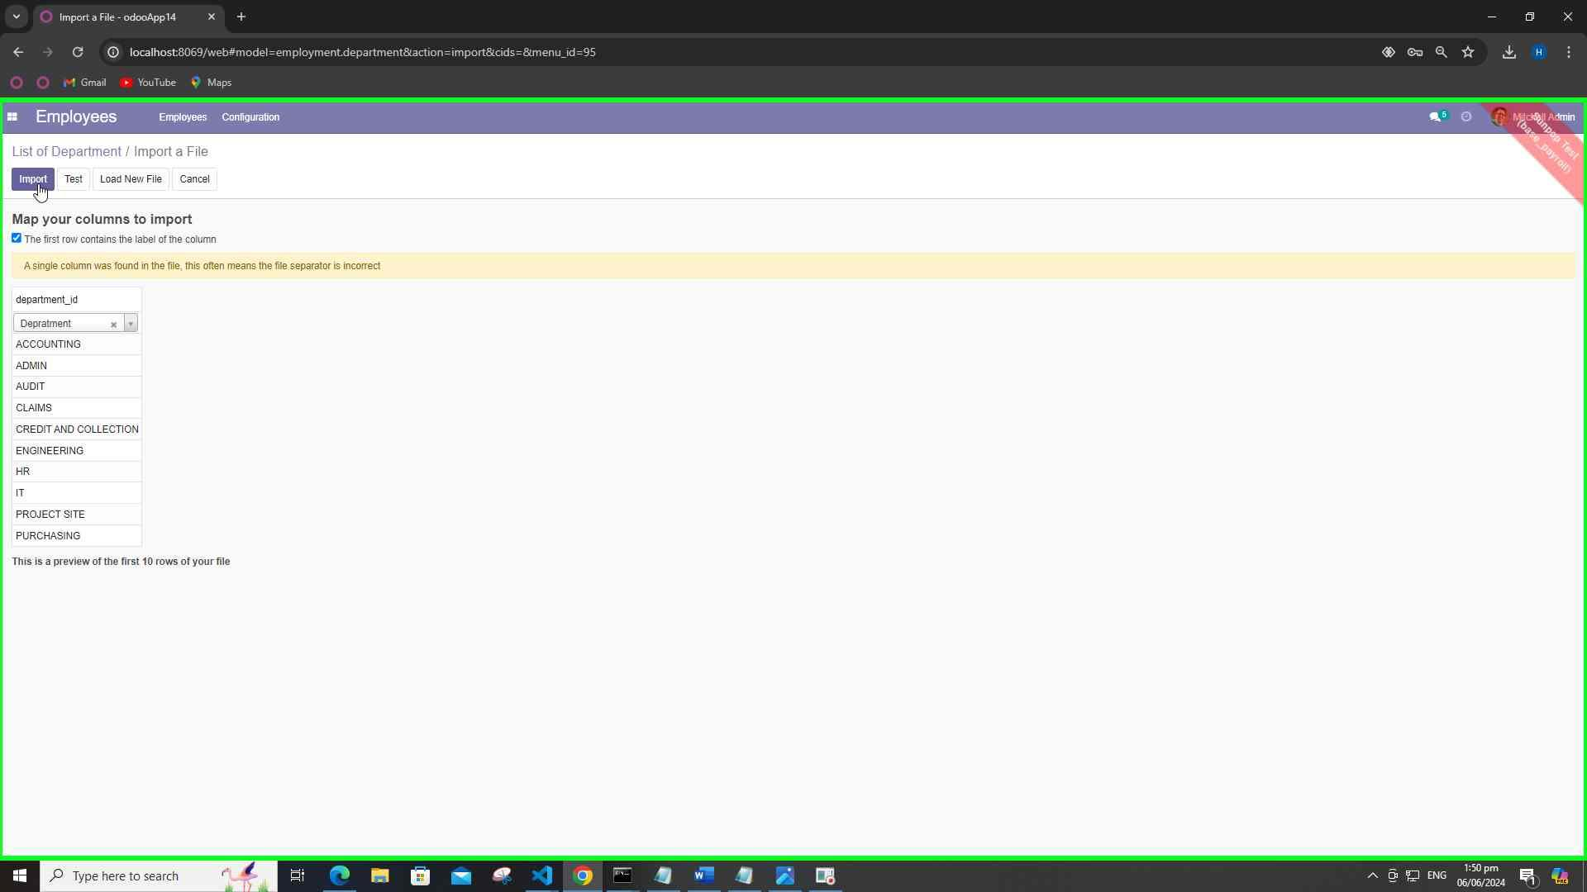

1. **Set Employee Data**
   * Indicate if an employee is exempted from DTR (Daily Time Record). Note: Admin account only can access this settings.

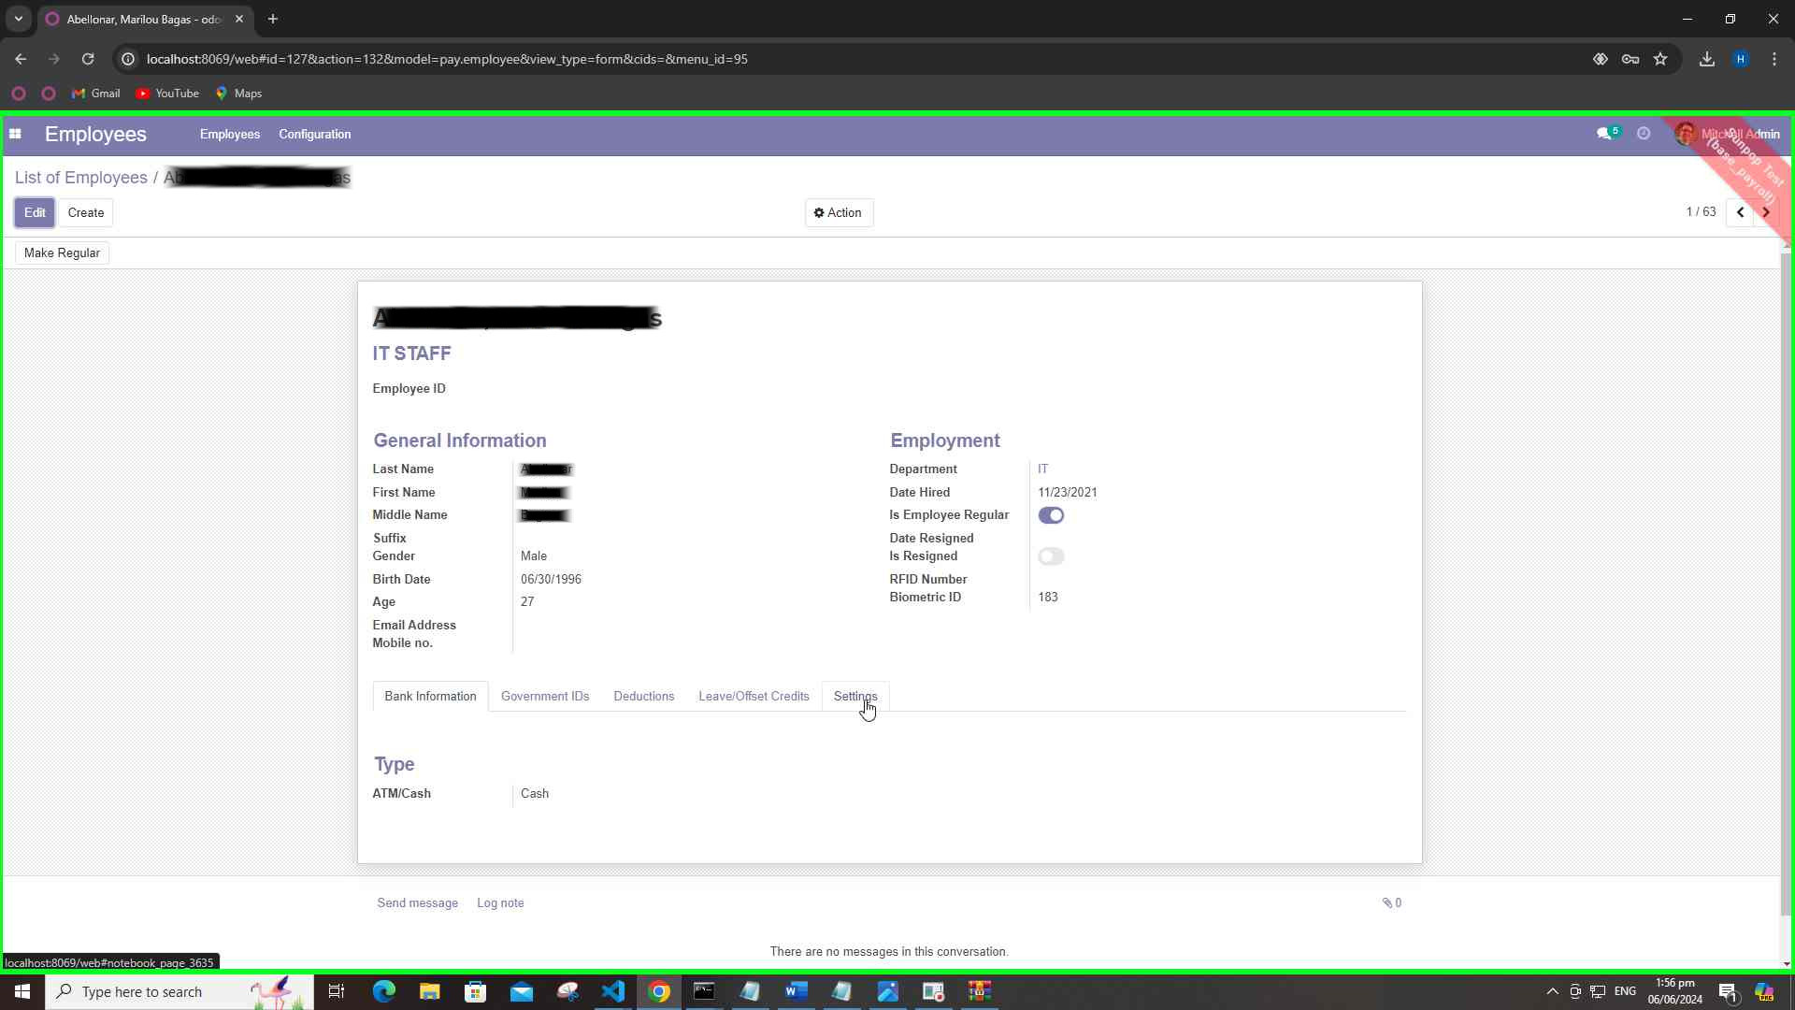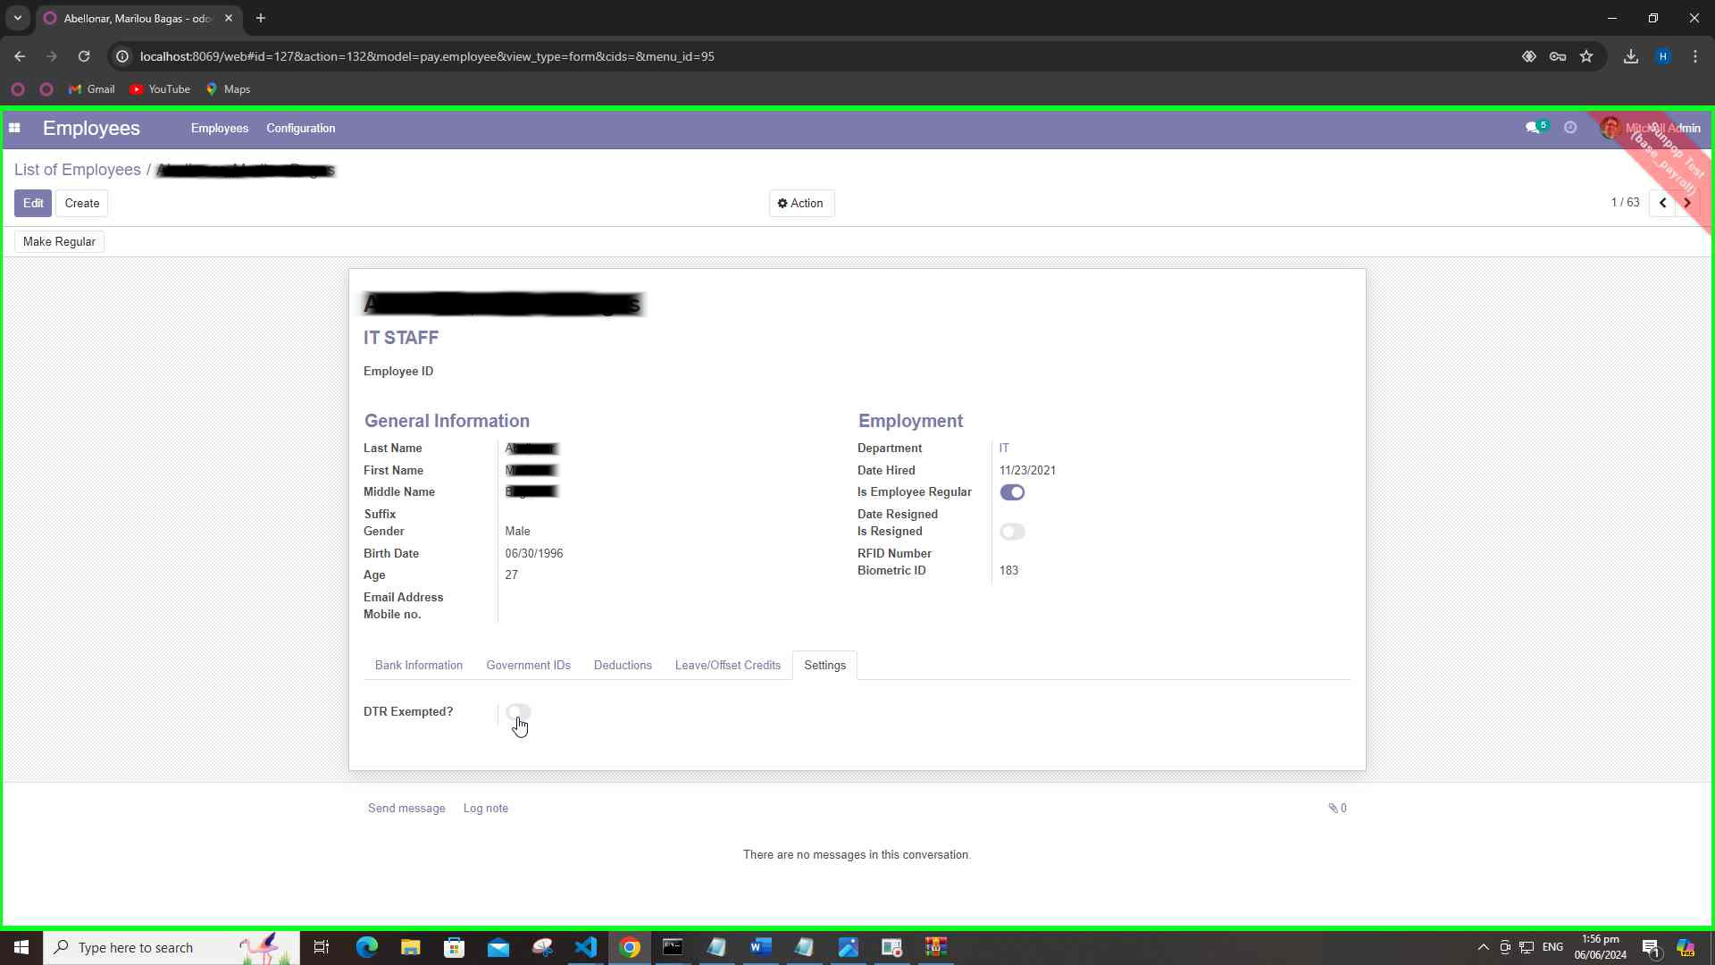

1. **Set Leave Credits**
   * At the beginning of each year (January), update the leave credits for all employees.

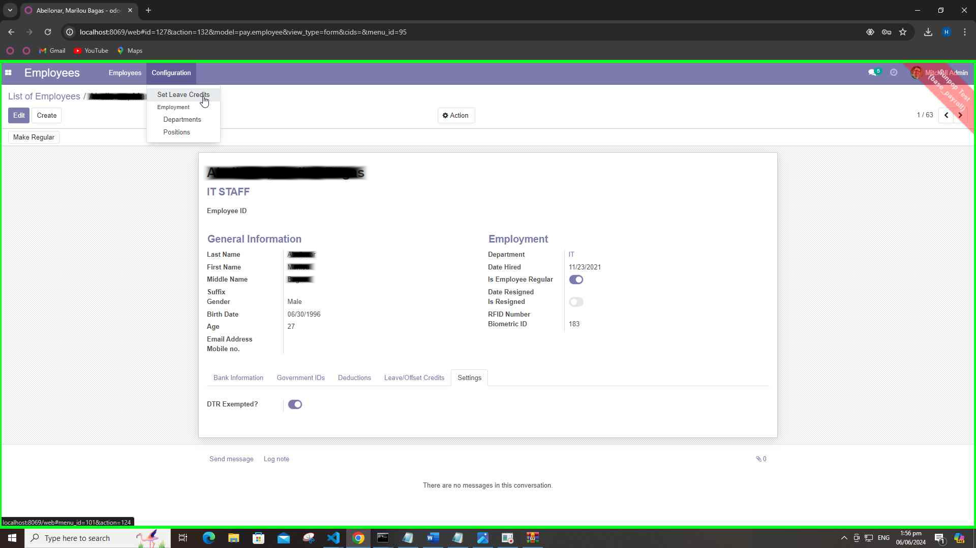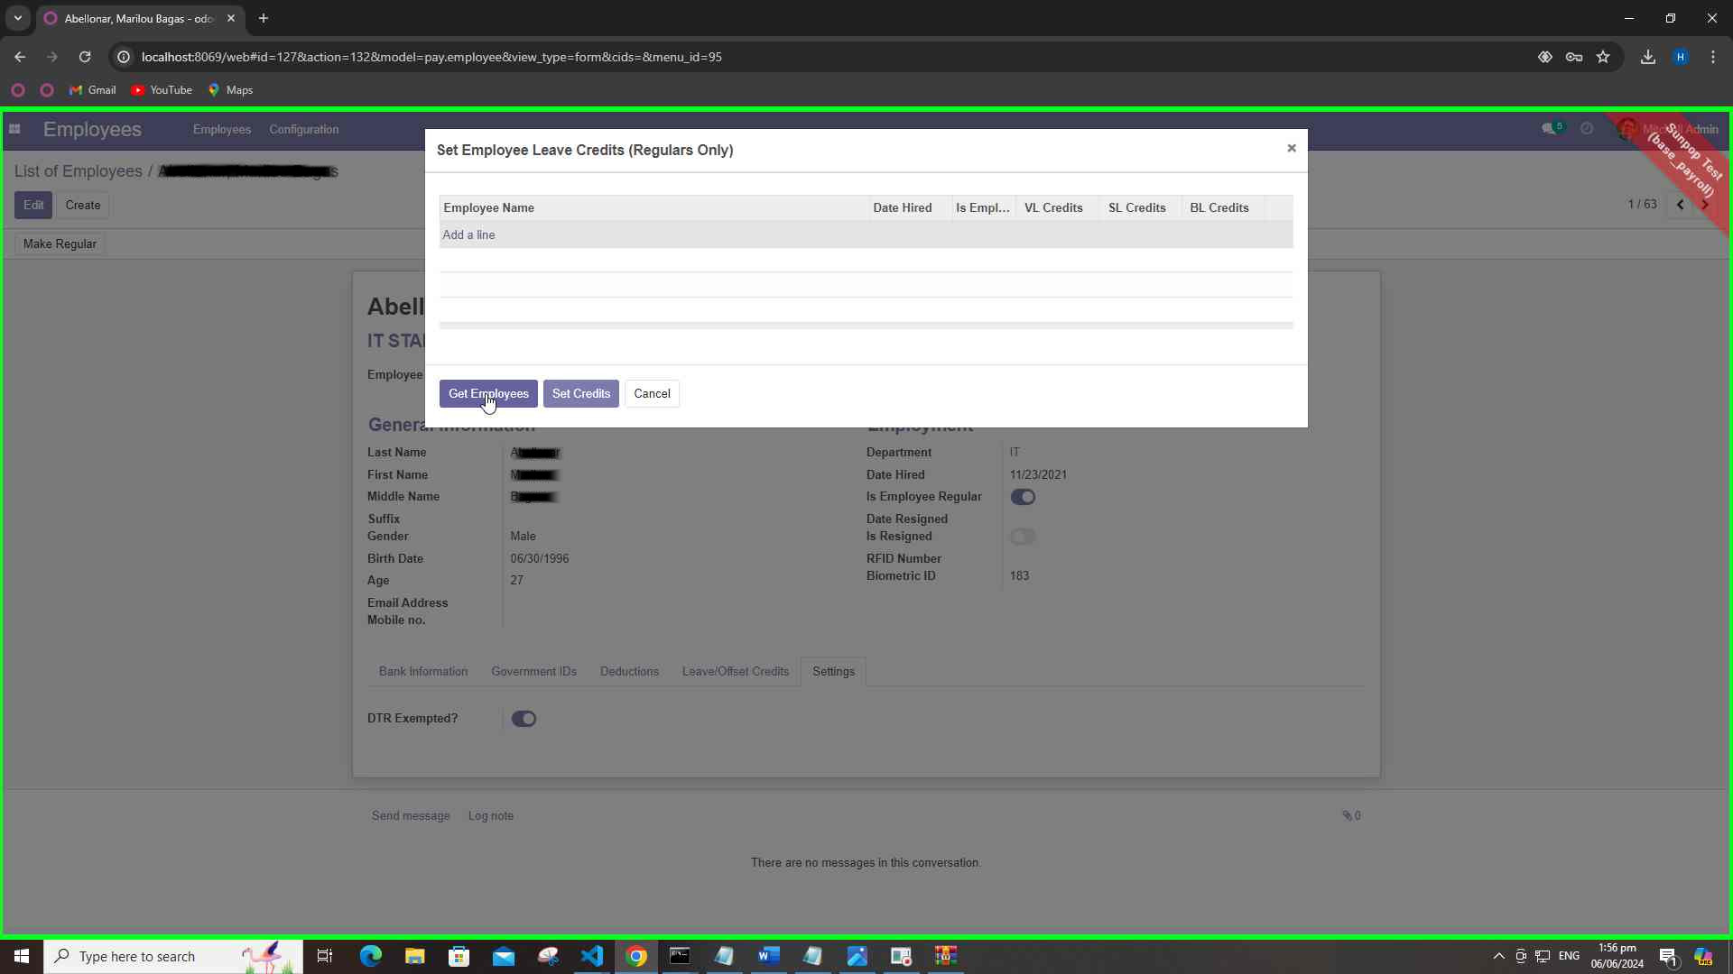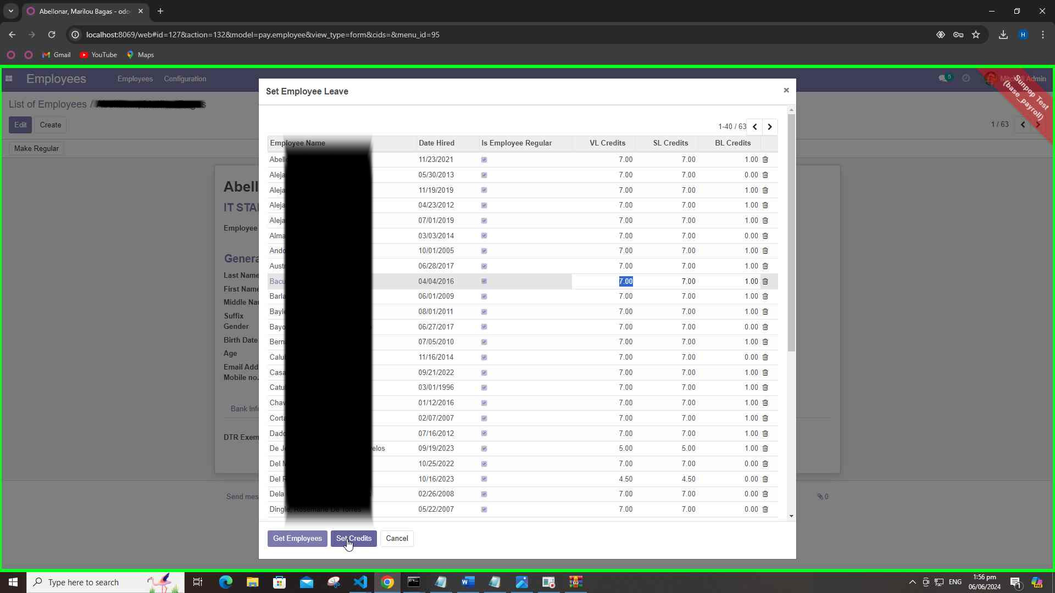

**DTR Dashboard**

1. **Create Paycode**
   * Generate a new paycode for the pay period.

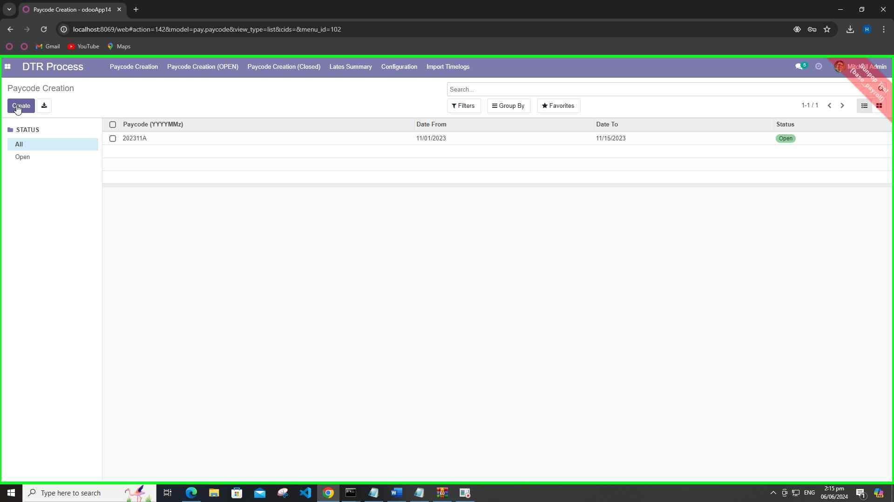

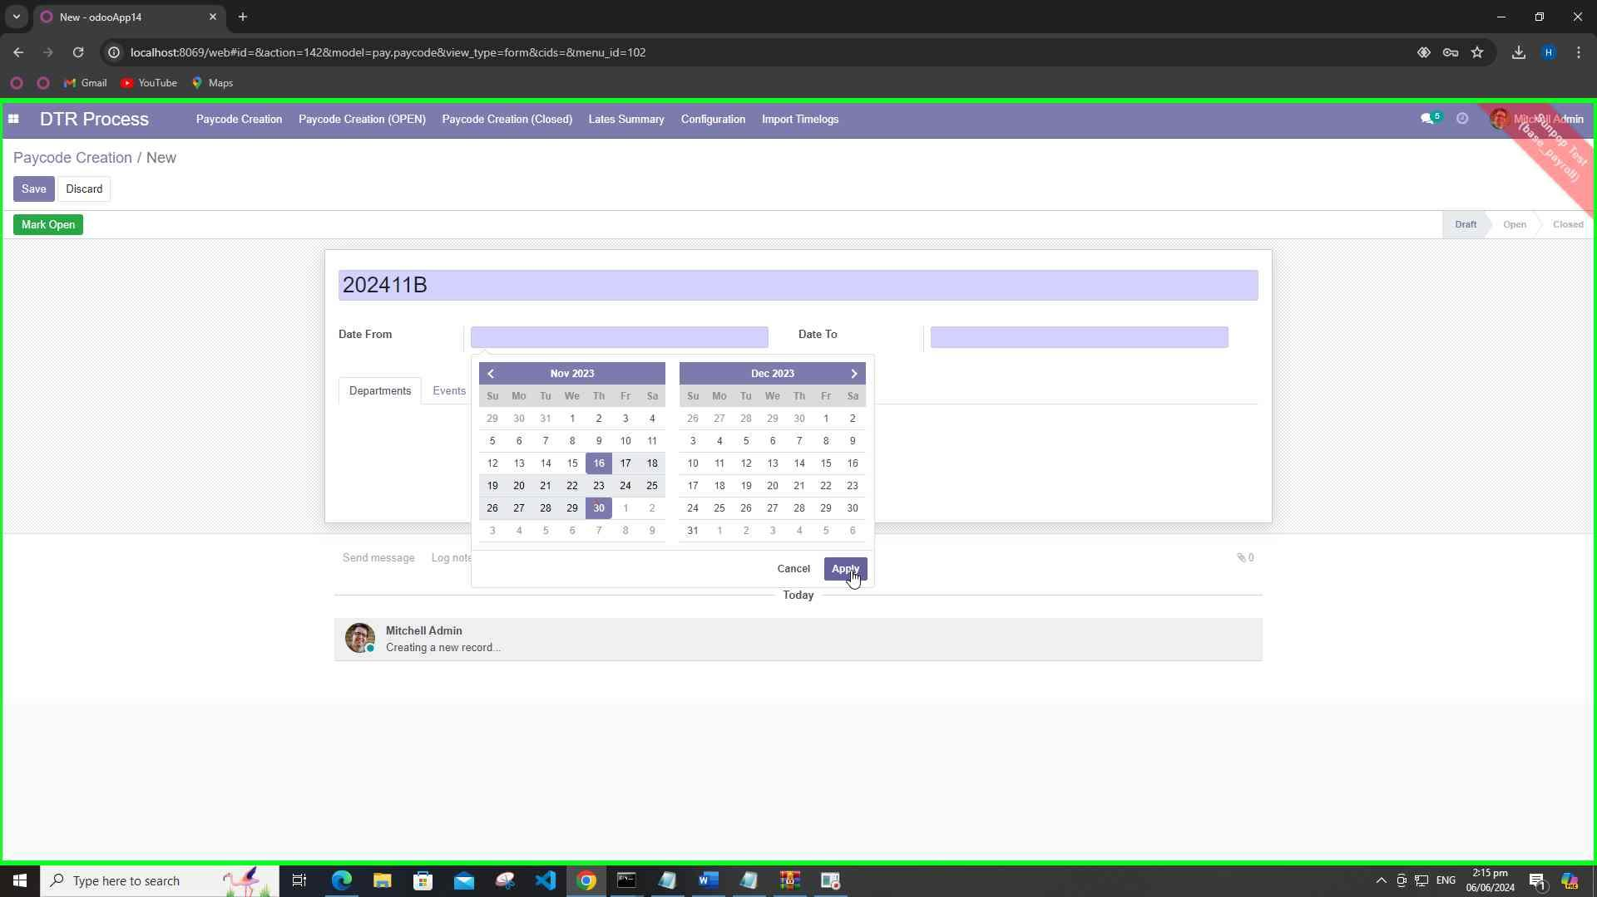

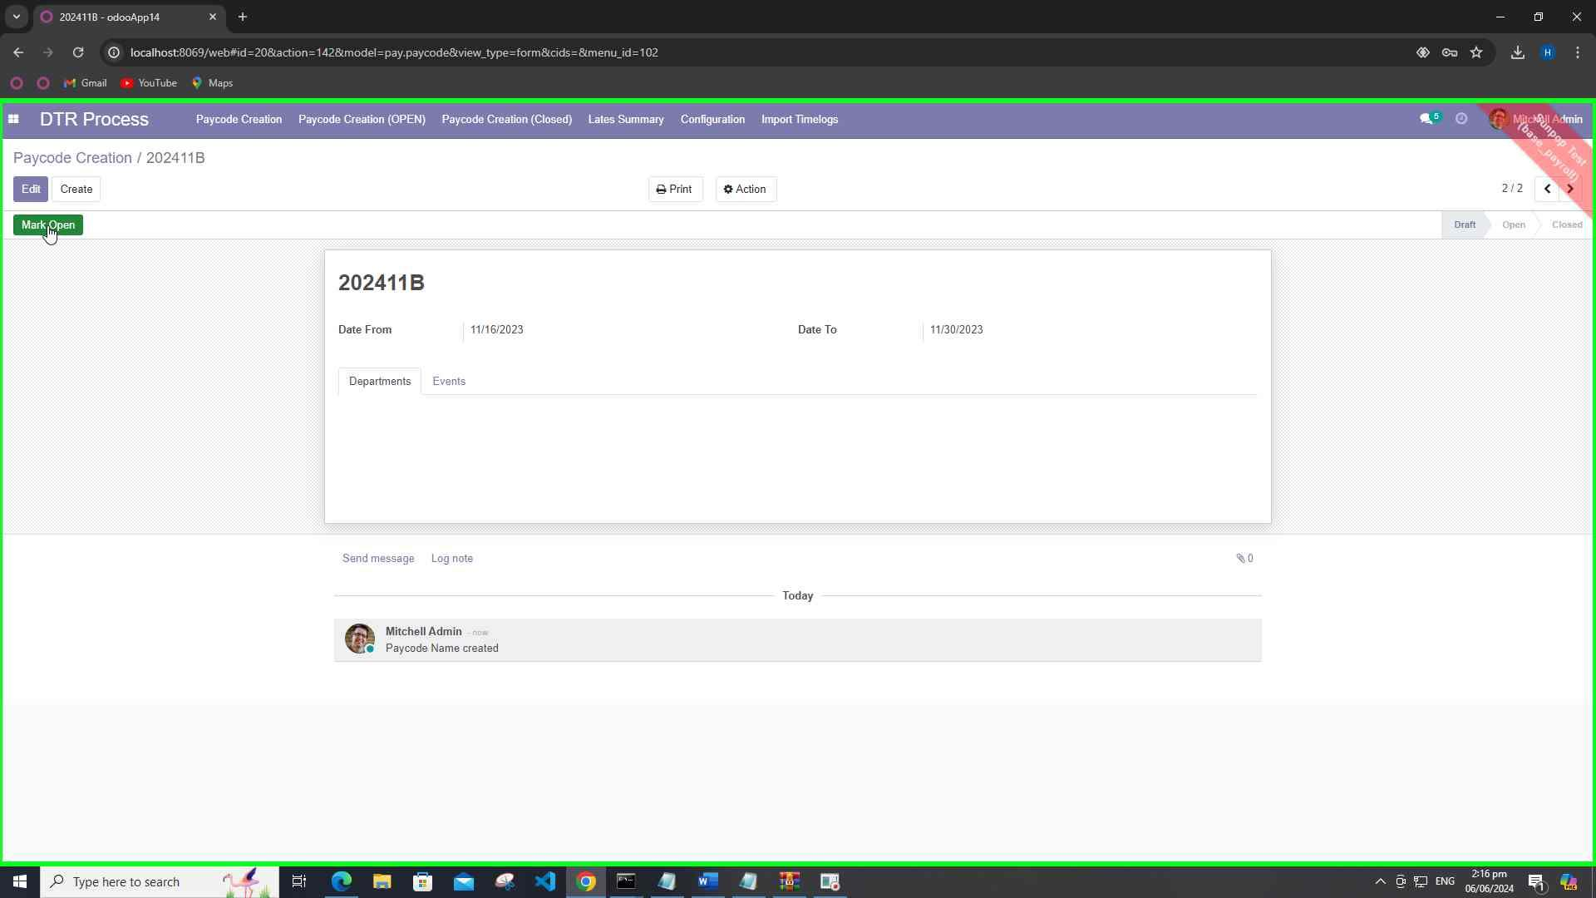

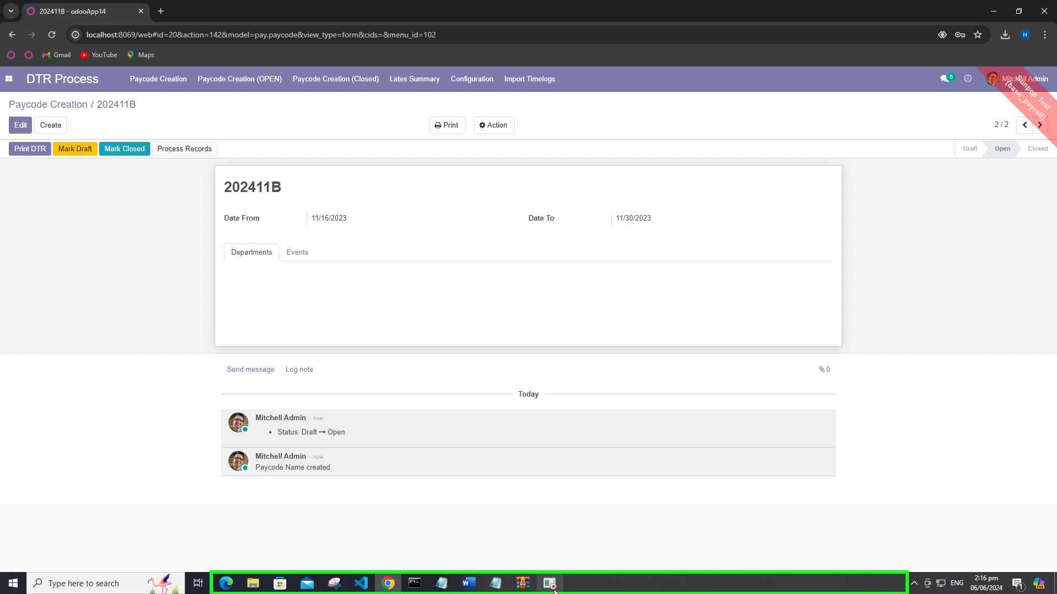

1. **Import Paycode File**
   * Upload the paycode file ( .dat file) containing time and biometric attendance data for processing.

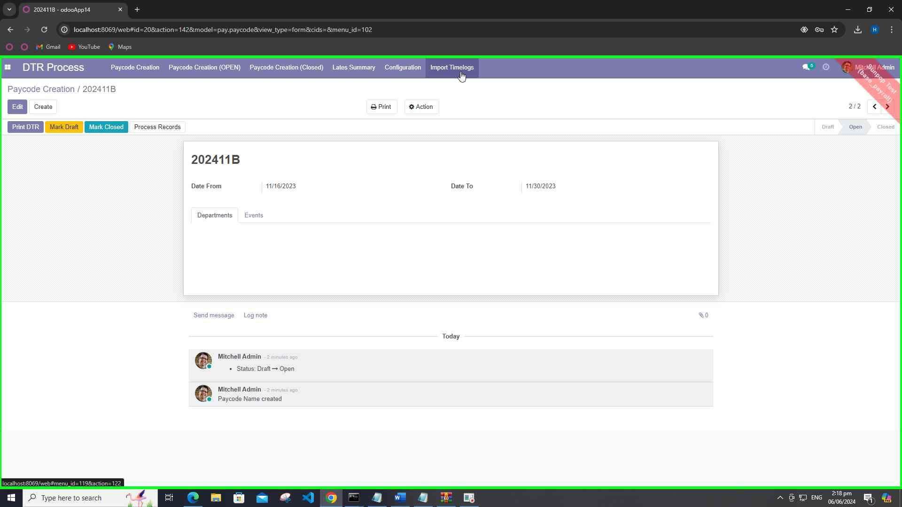

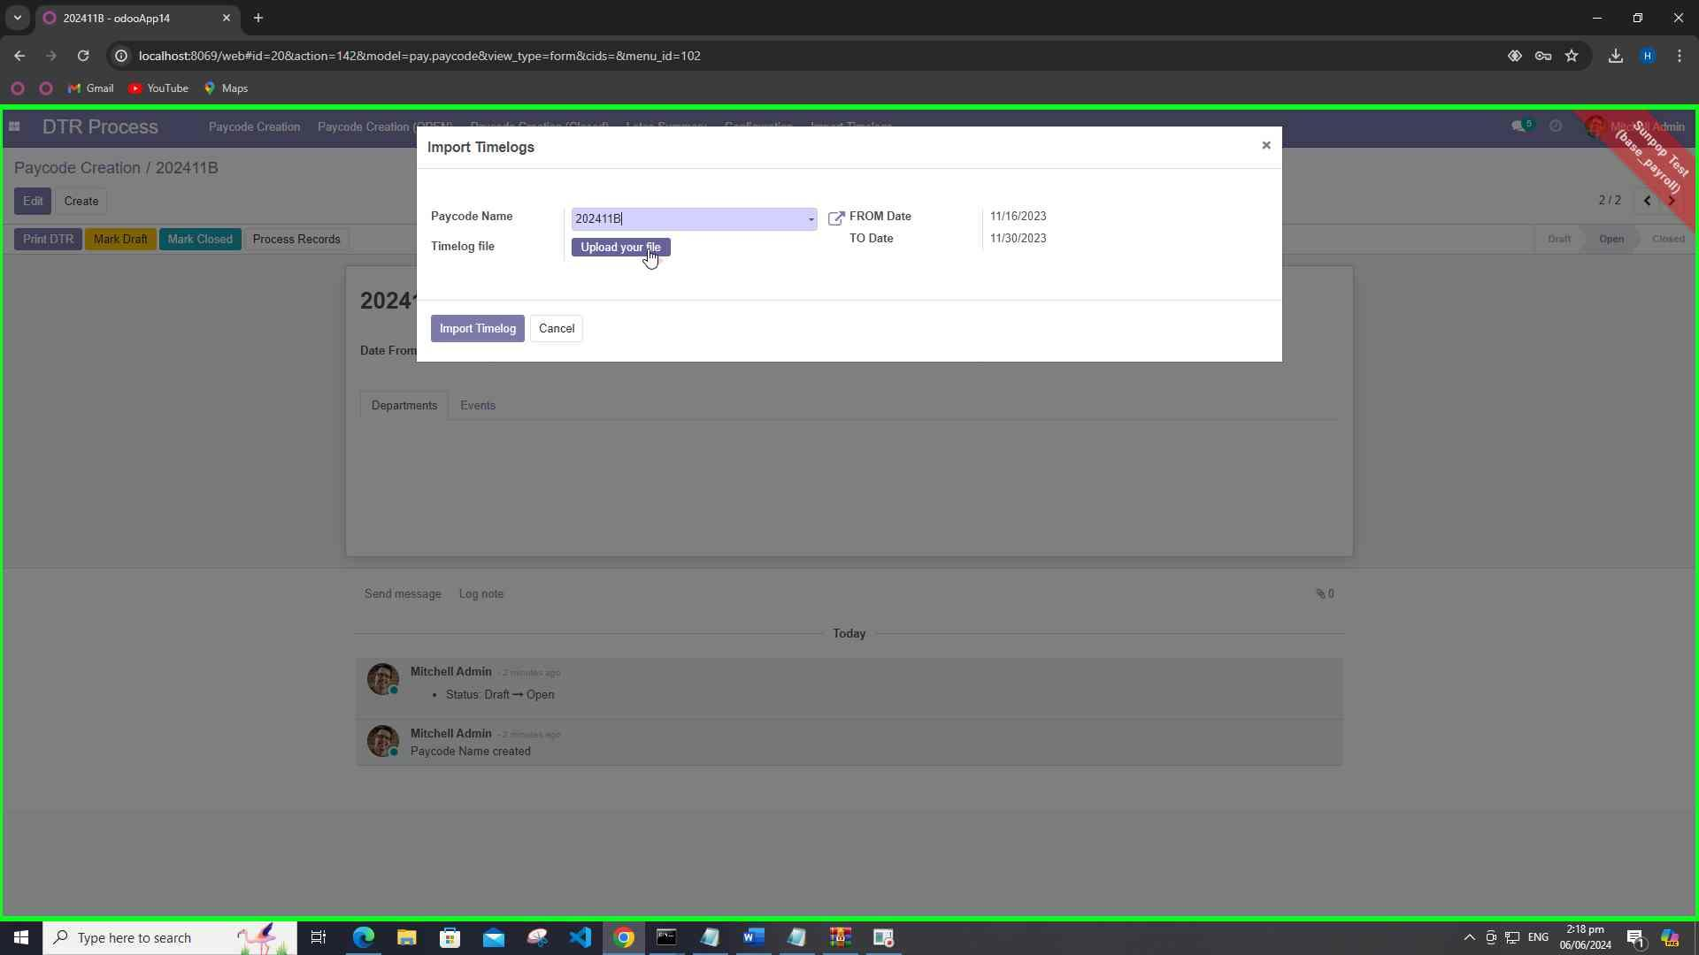

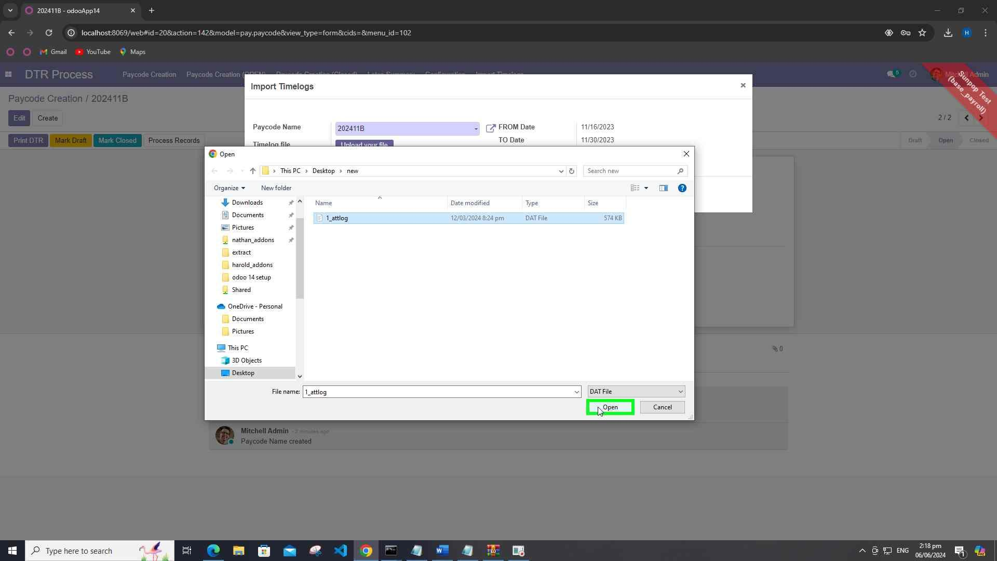

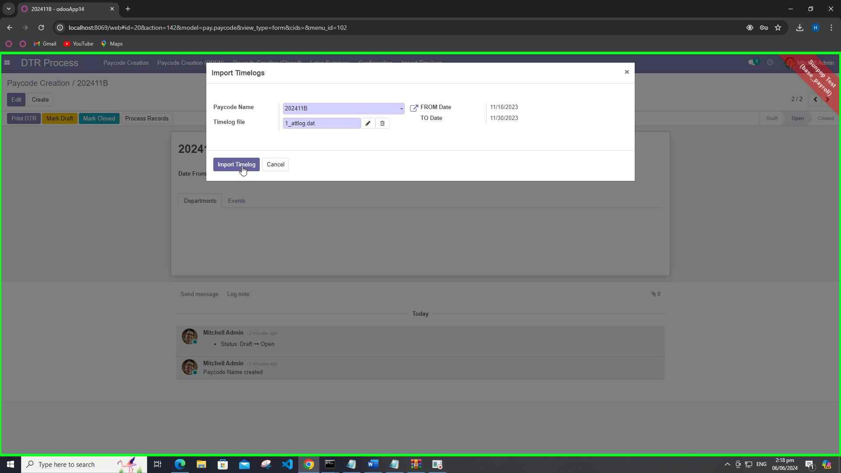

1. **HR Forms Dashboard**
   * **Leave**: Manage leave requests and approvals.
   * **Overtime**: Manage overtime requests and approvals.
   * **Offset**: Manage offset requests and approvals.
   * **Undertime**: Manage undertime requests and approvals.

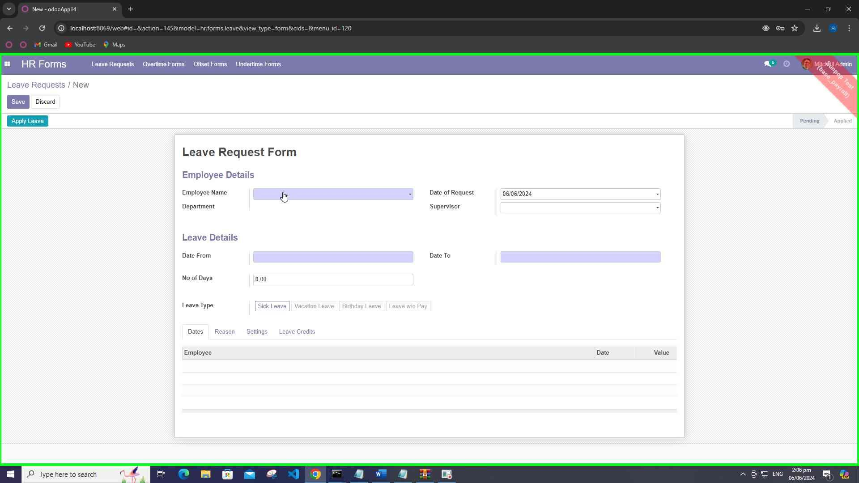

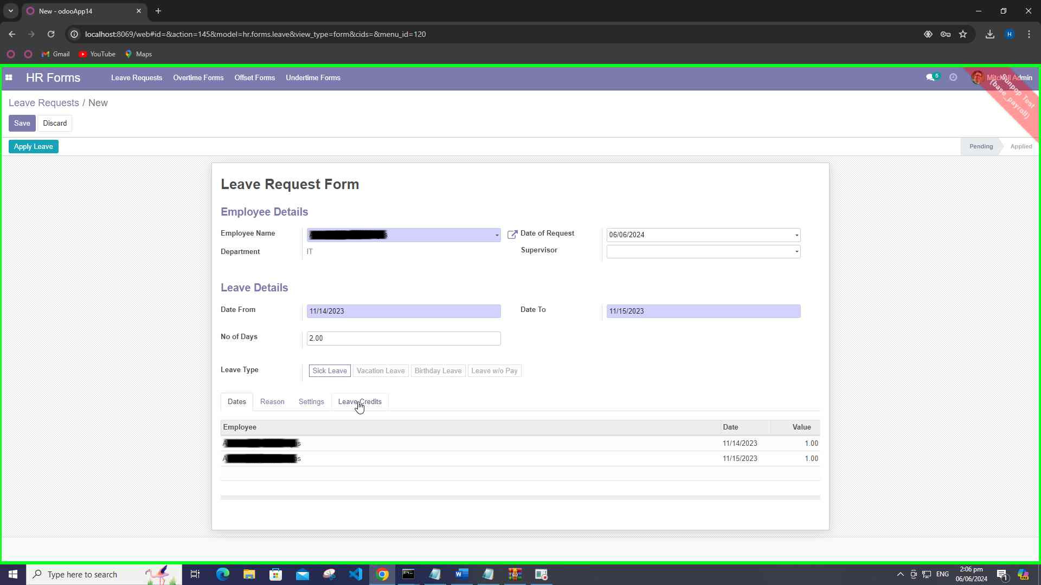

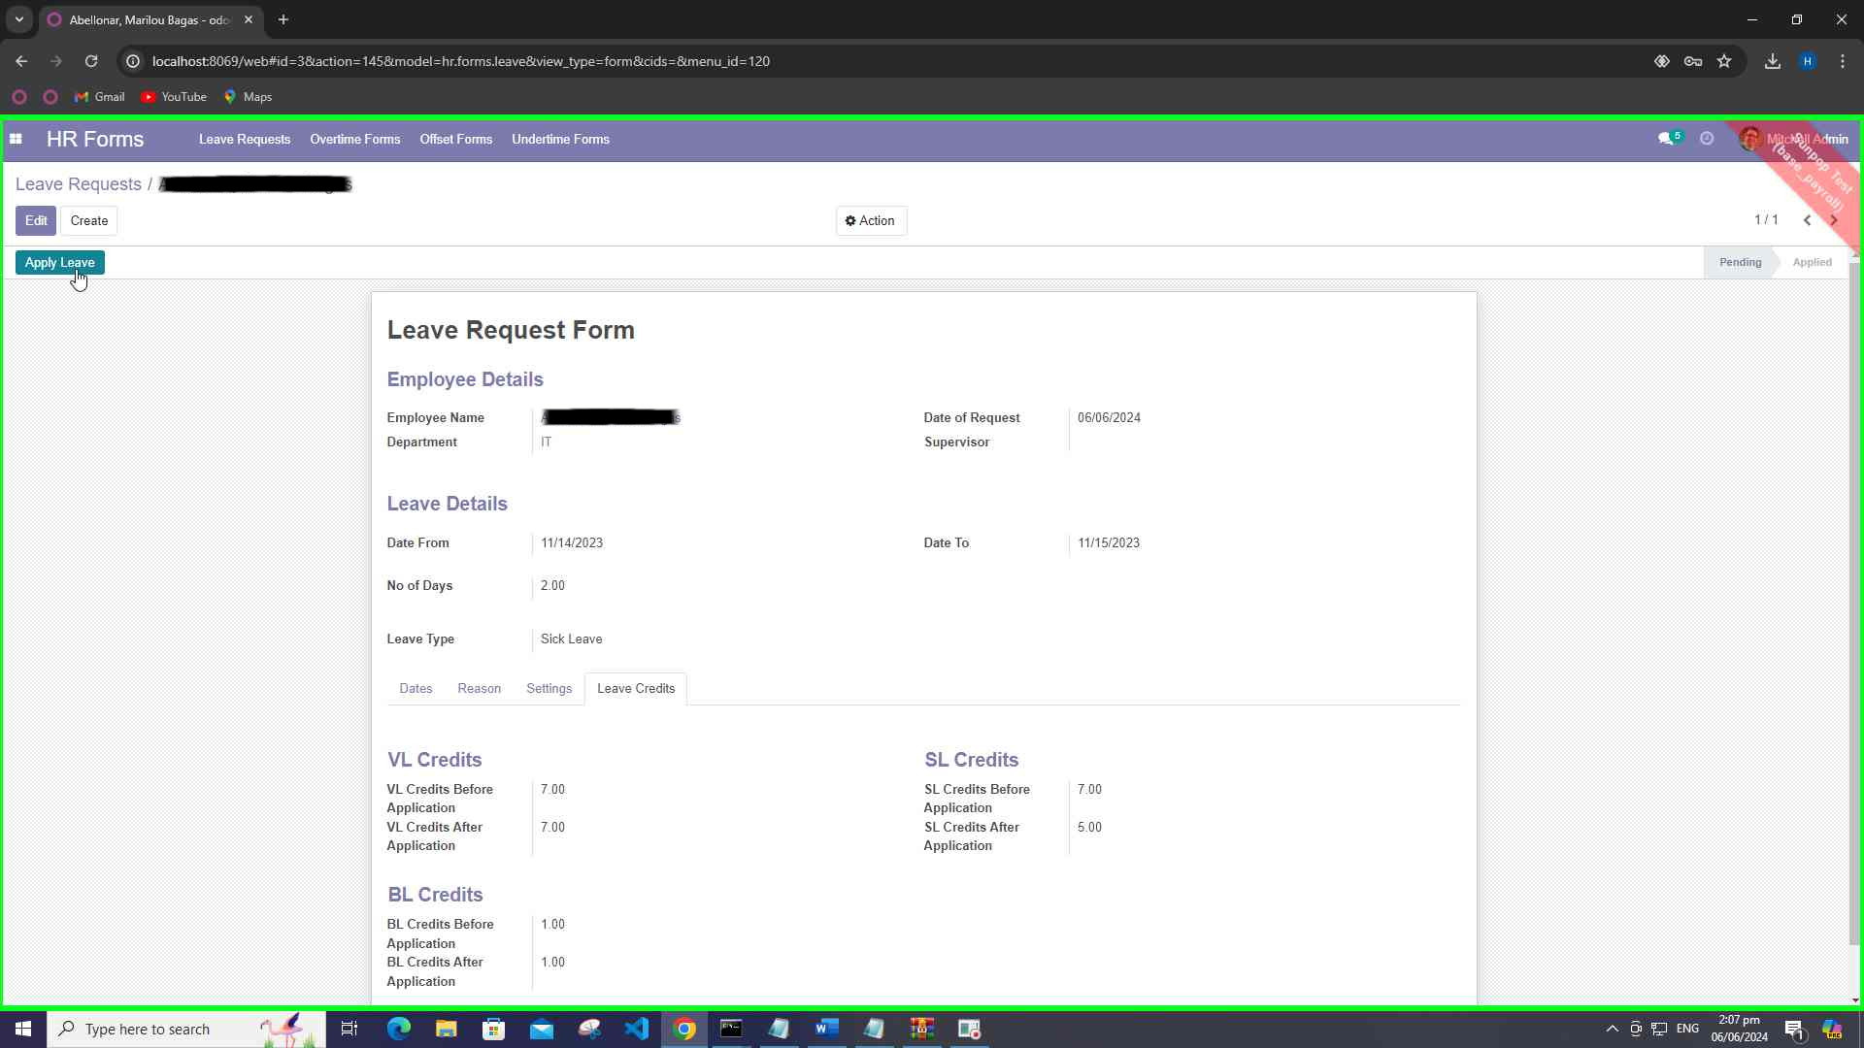

1. **Process Record on Paycode**
   * Process the uploaded paycode file to generate attendance records.

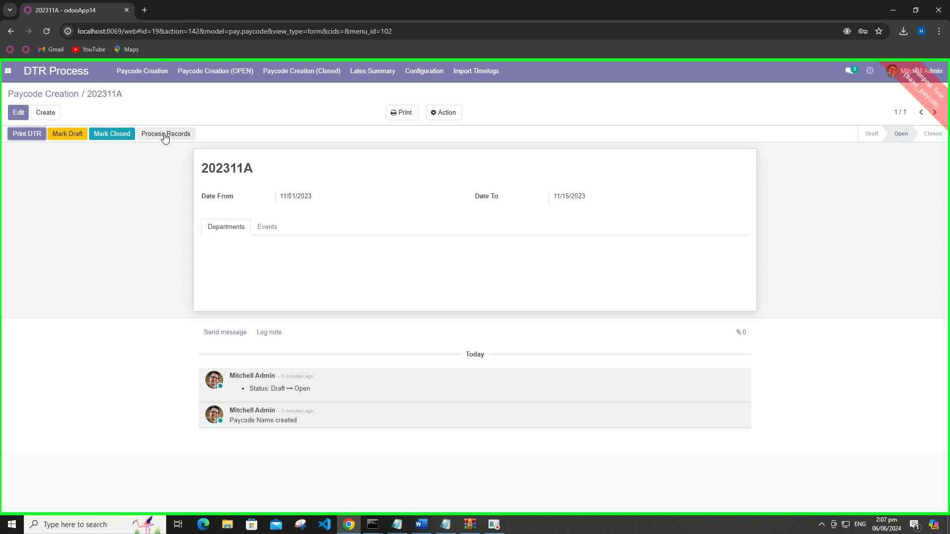

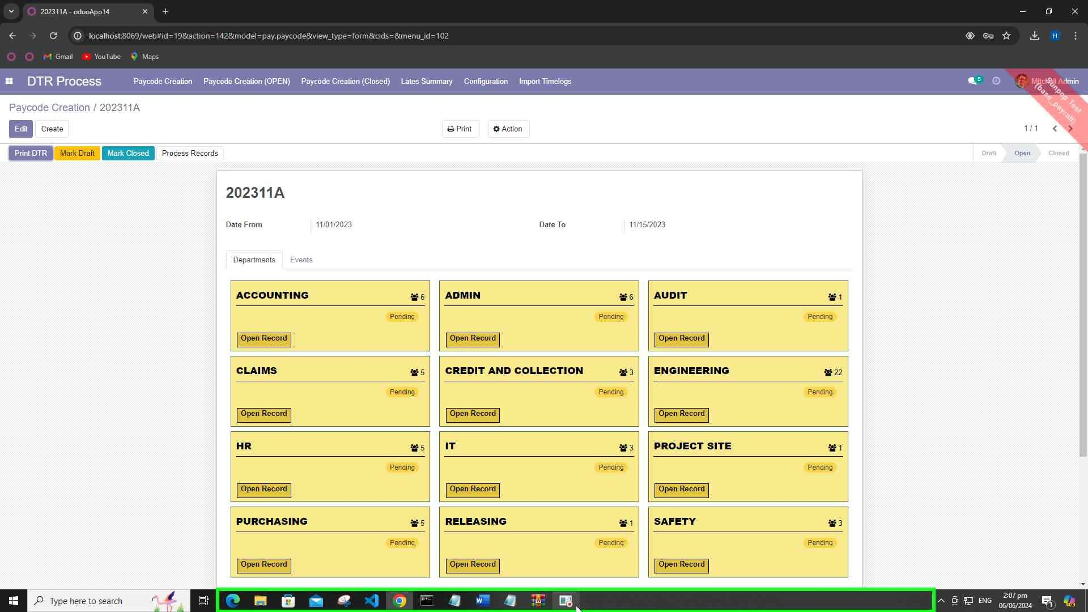

1. **Print Paycode DTR Report**
   * Generate and print the DTR report for the paycode. Distribute the report to employees for their review.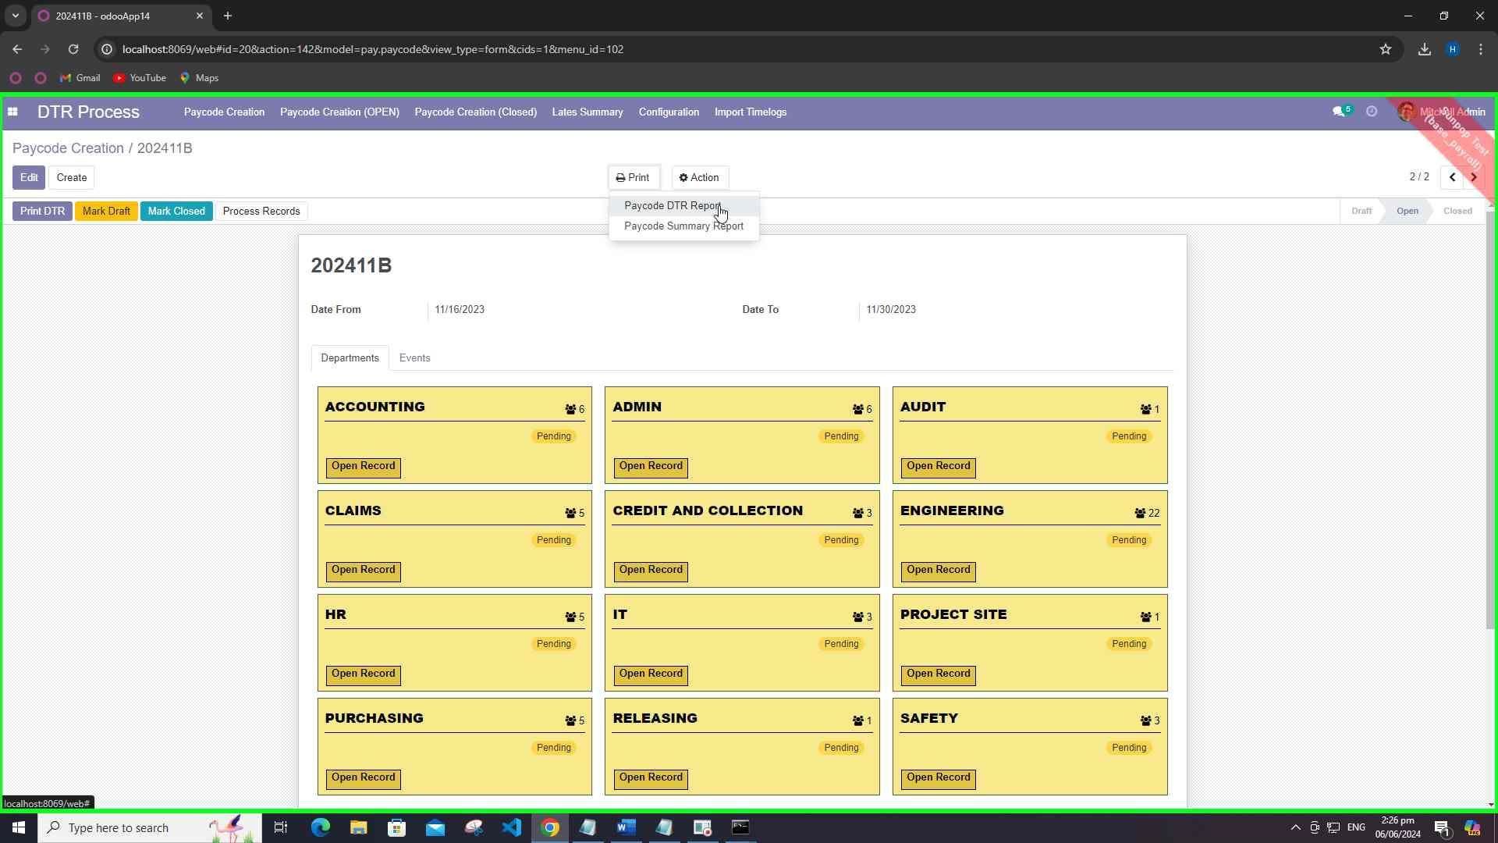

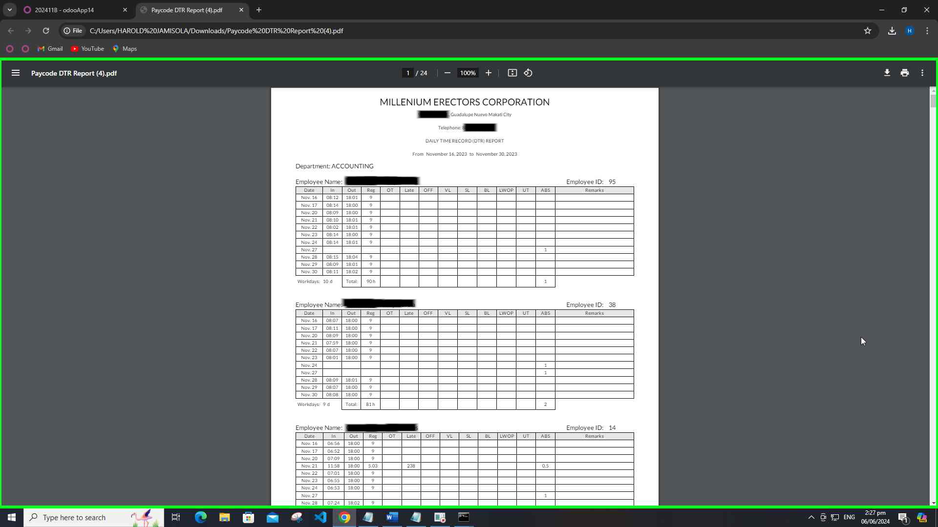

1. **Fix Paycode Employee Data**
   * **Identify** **Discrepancies**: Verify and check for cases where the punch-in and punch-out times are the same or other anomalies based on predefined rules. (Examples: False punch like time in is 18:05 and time out is also 18:05)
   * **Validate**: Before correcting, verify data to ensure they have no errors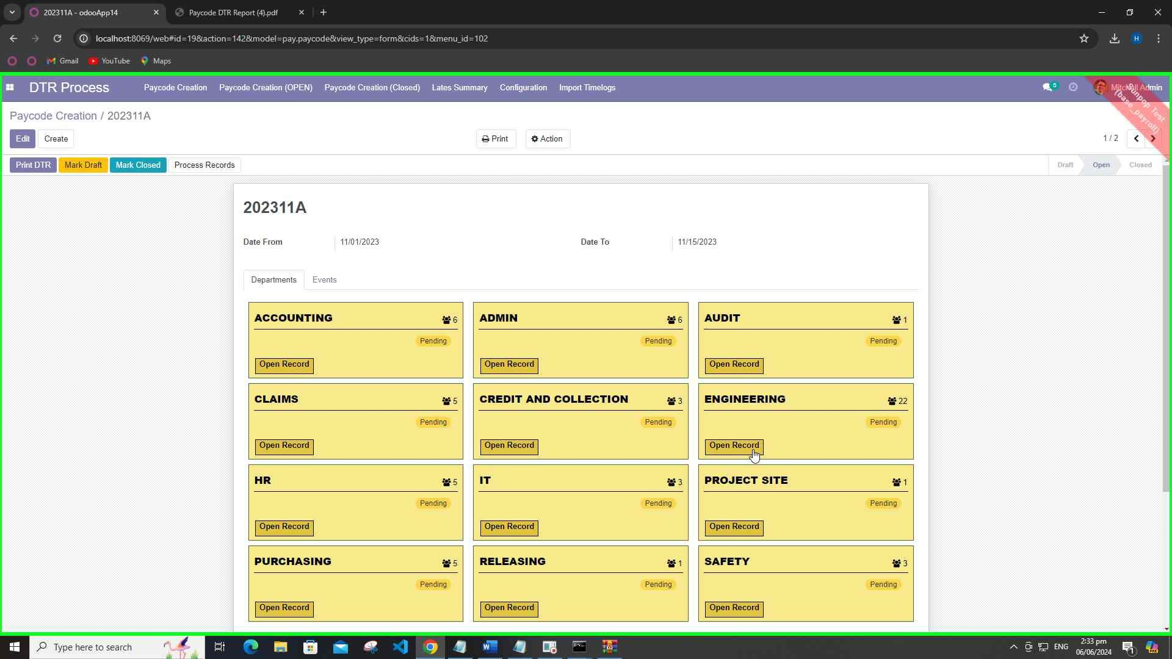

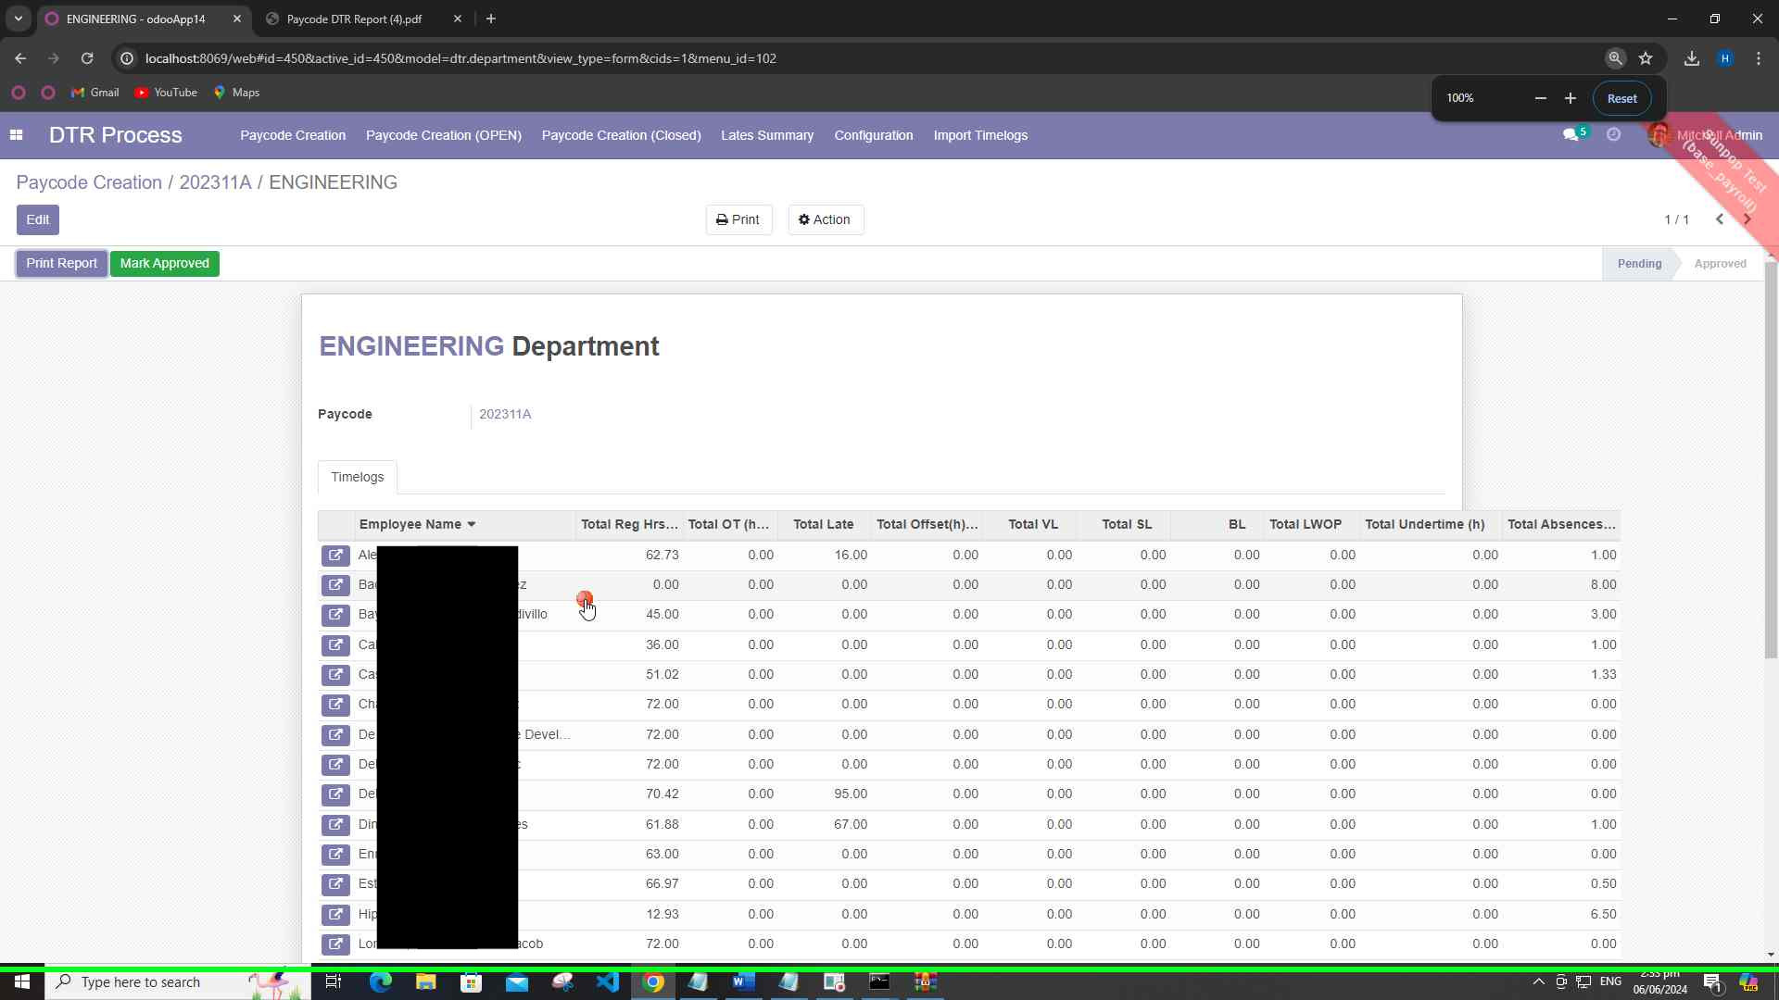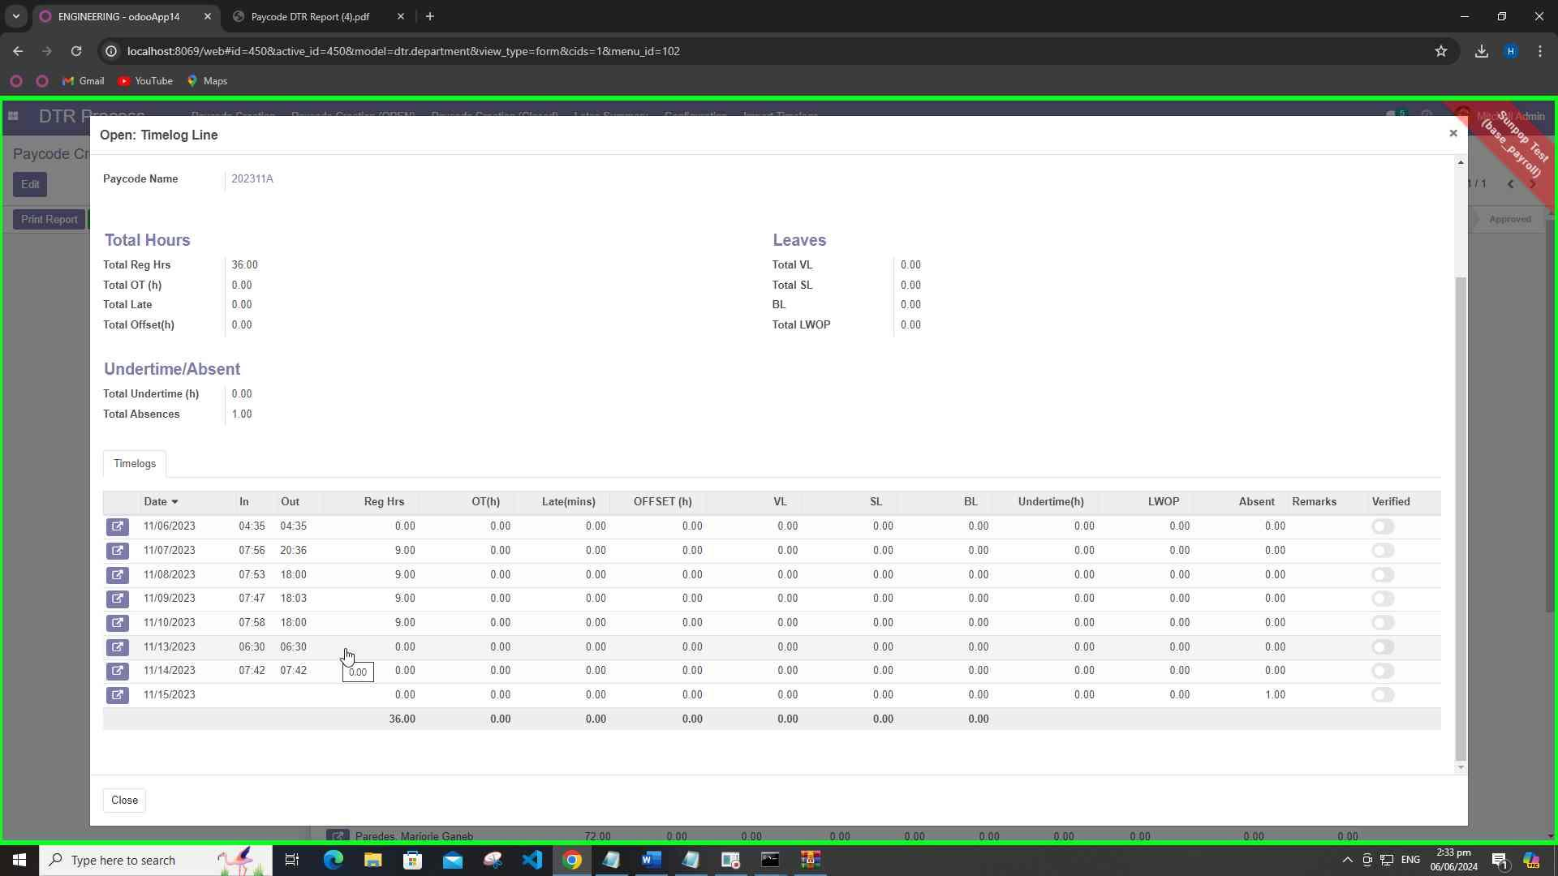

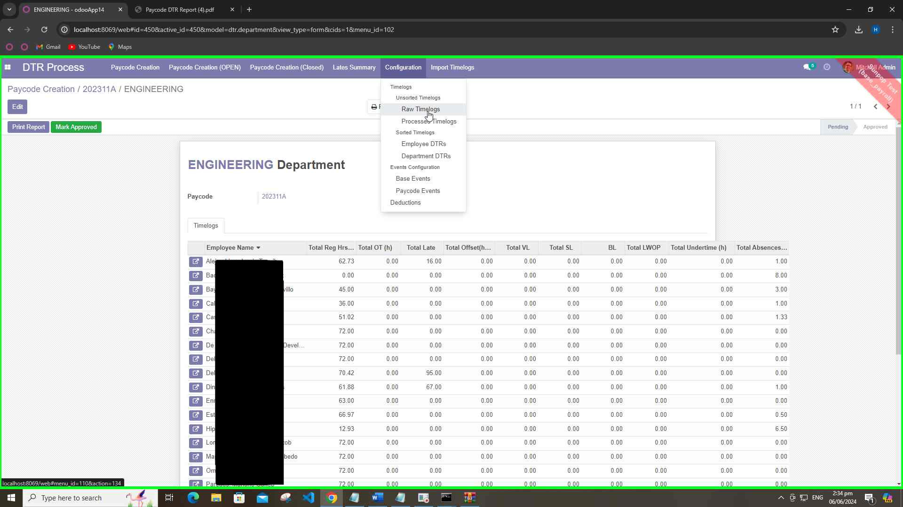

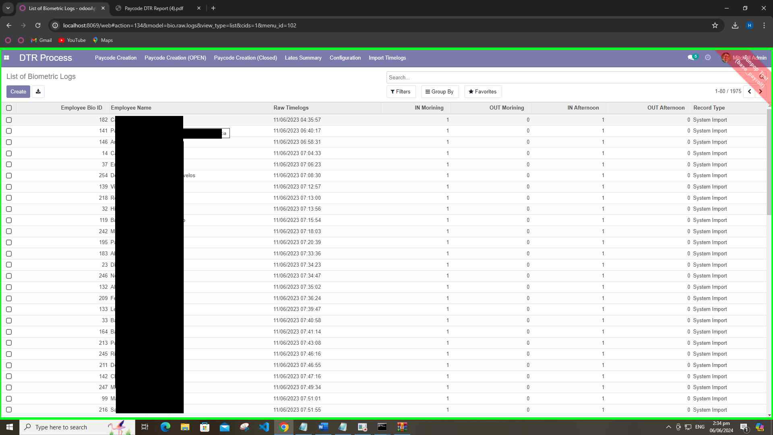

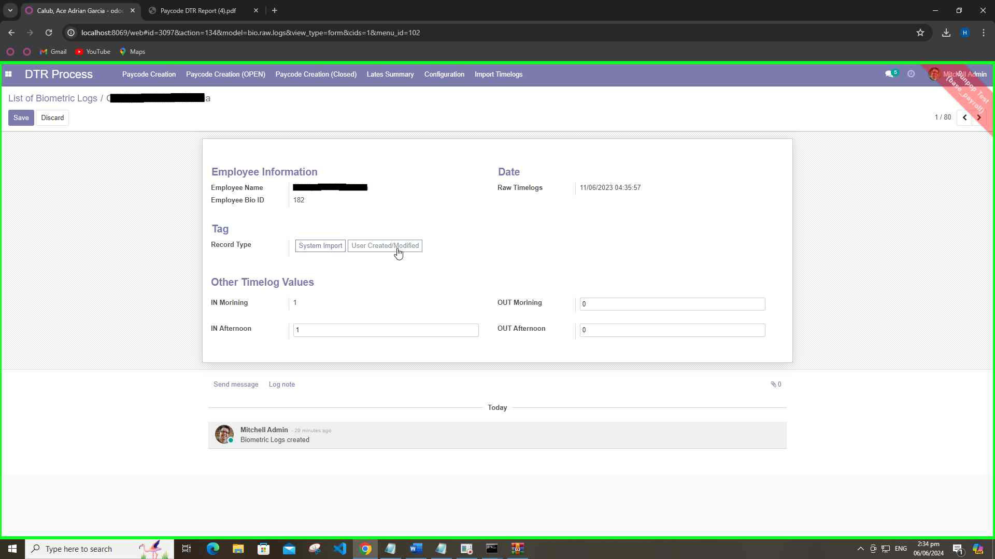

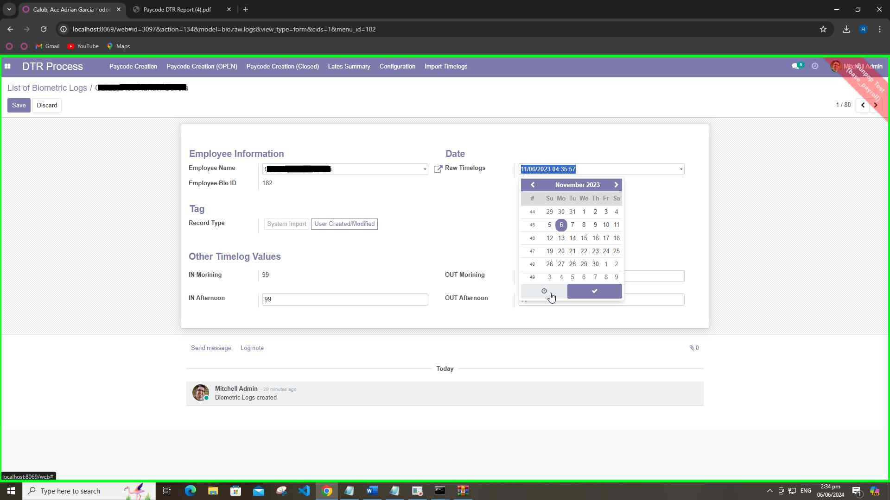

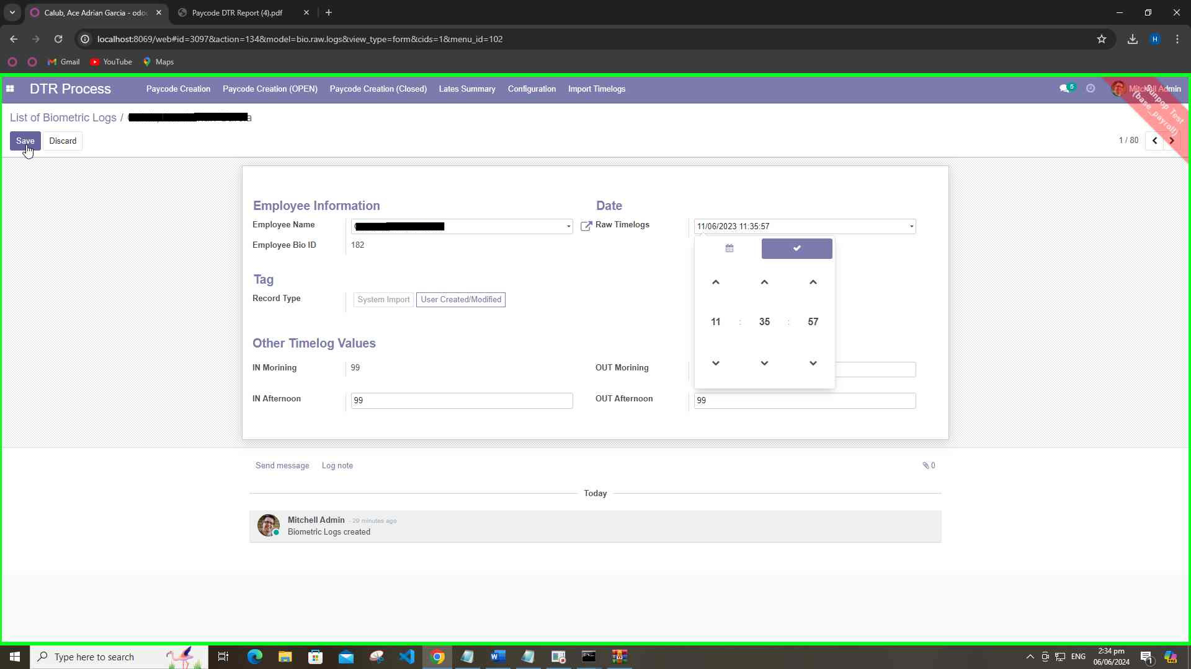

1. **Process Record on Paycode Again**
   * Reprocess the paycode file after corrections.
2. **Create Late Summary**
   * Compile a summary of late arrivals based on month. The summary should categorize the late arrivals into two pay codes(eg., 202311A and 202311B).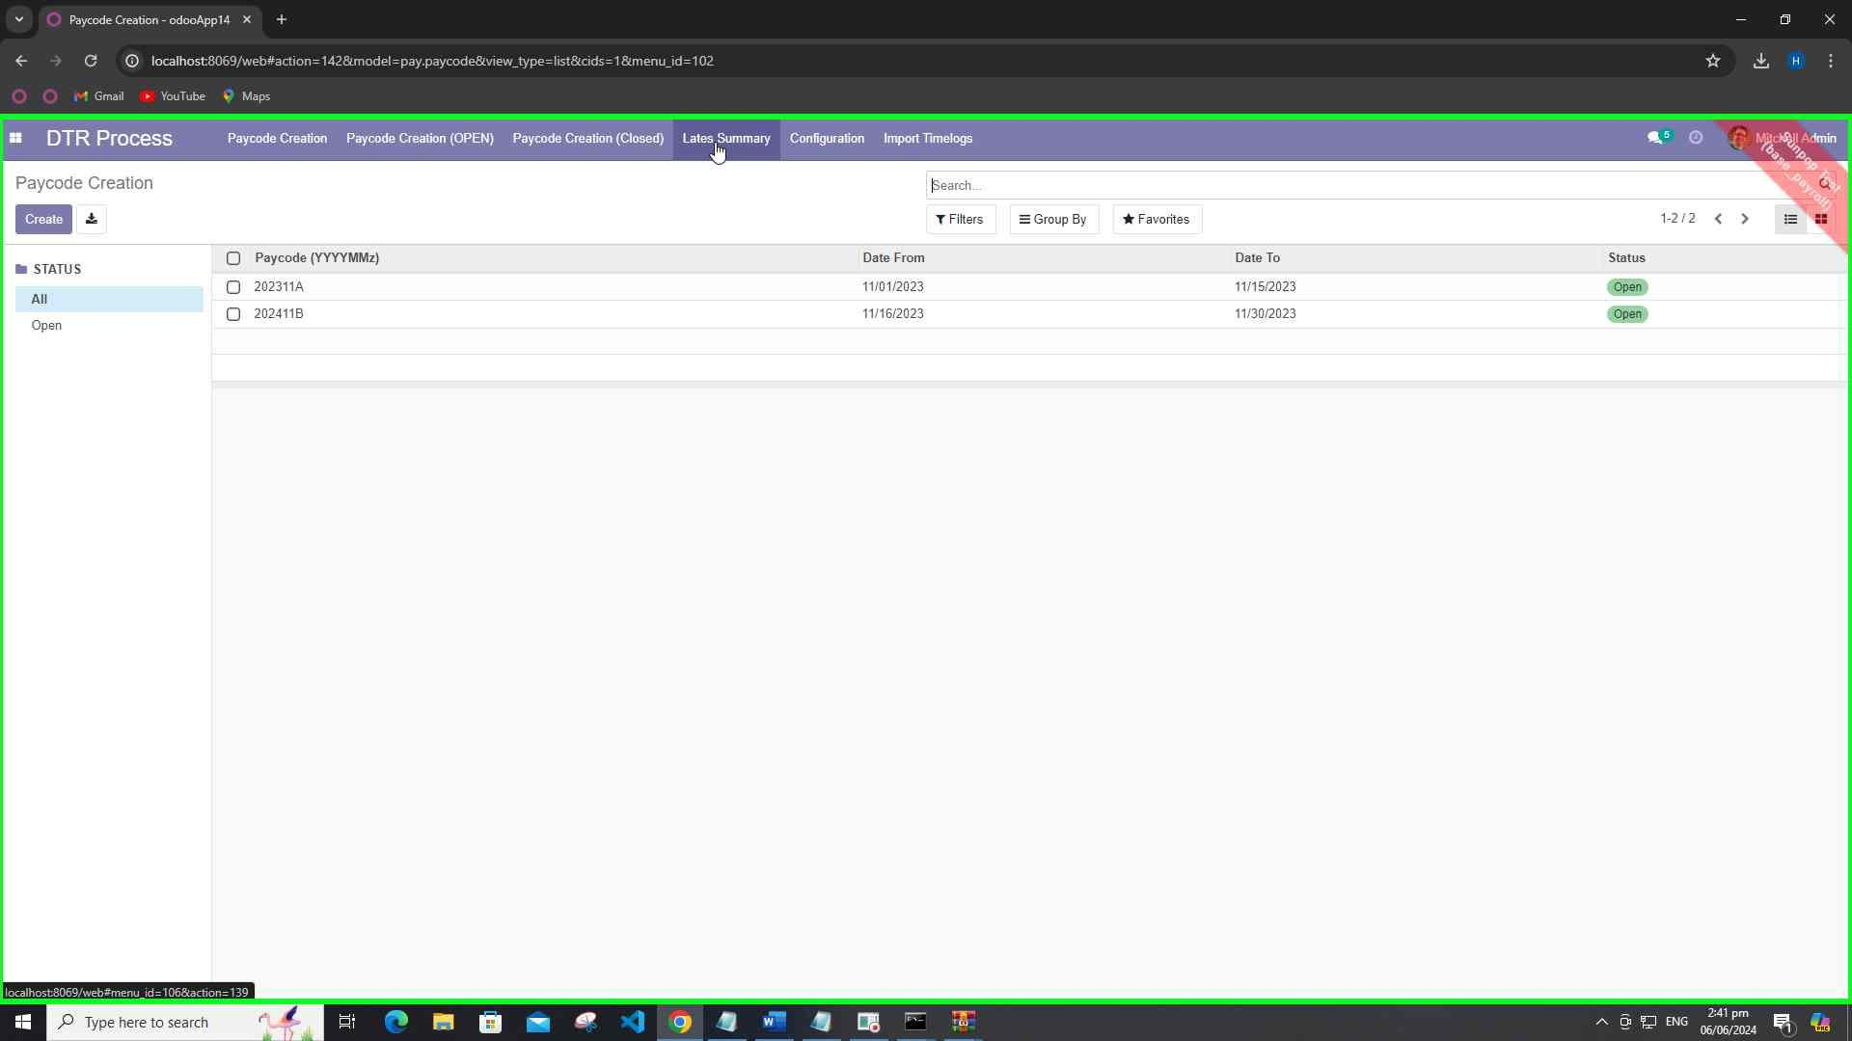

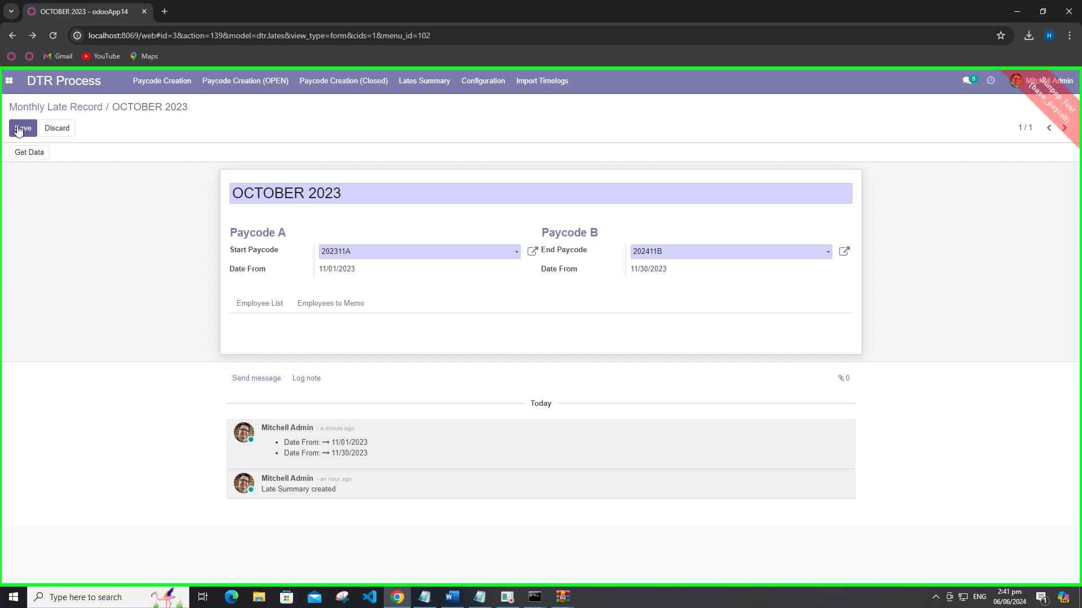

1. **Print Late Summary Report**
   * Generate and print the Late Summary Report.

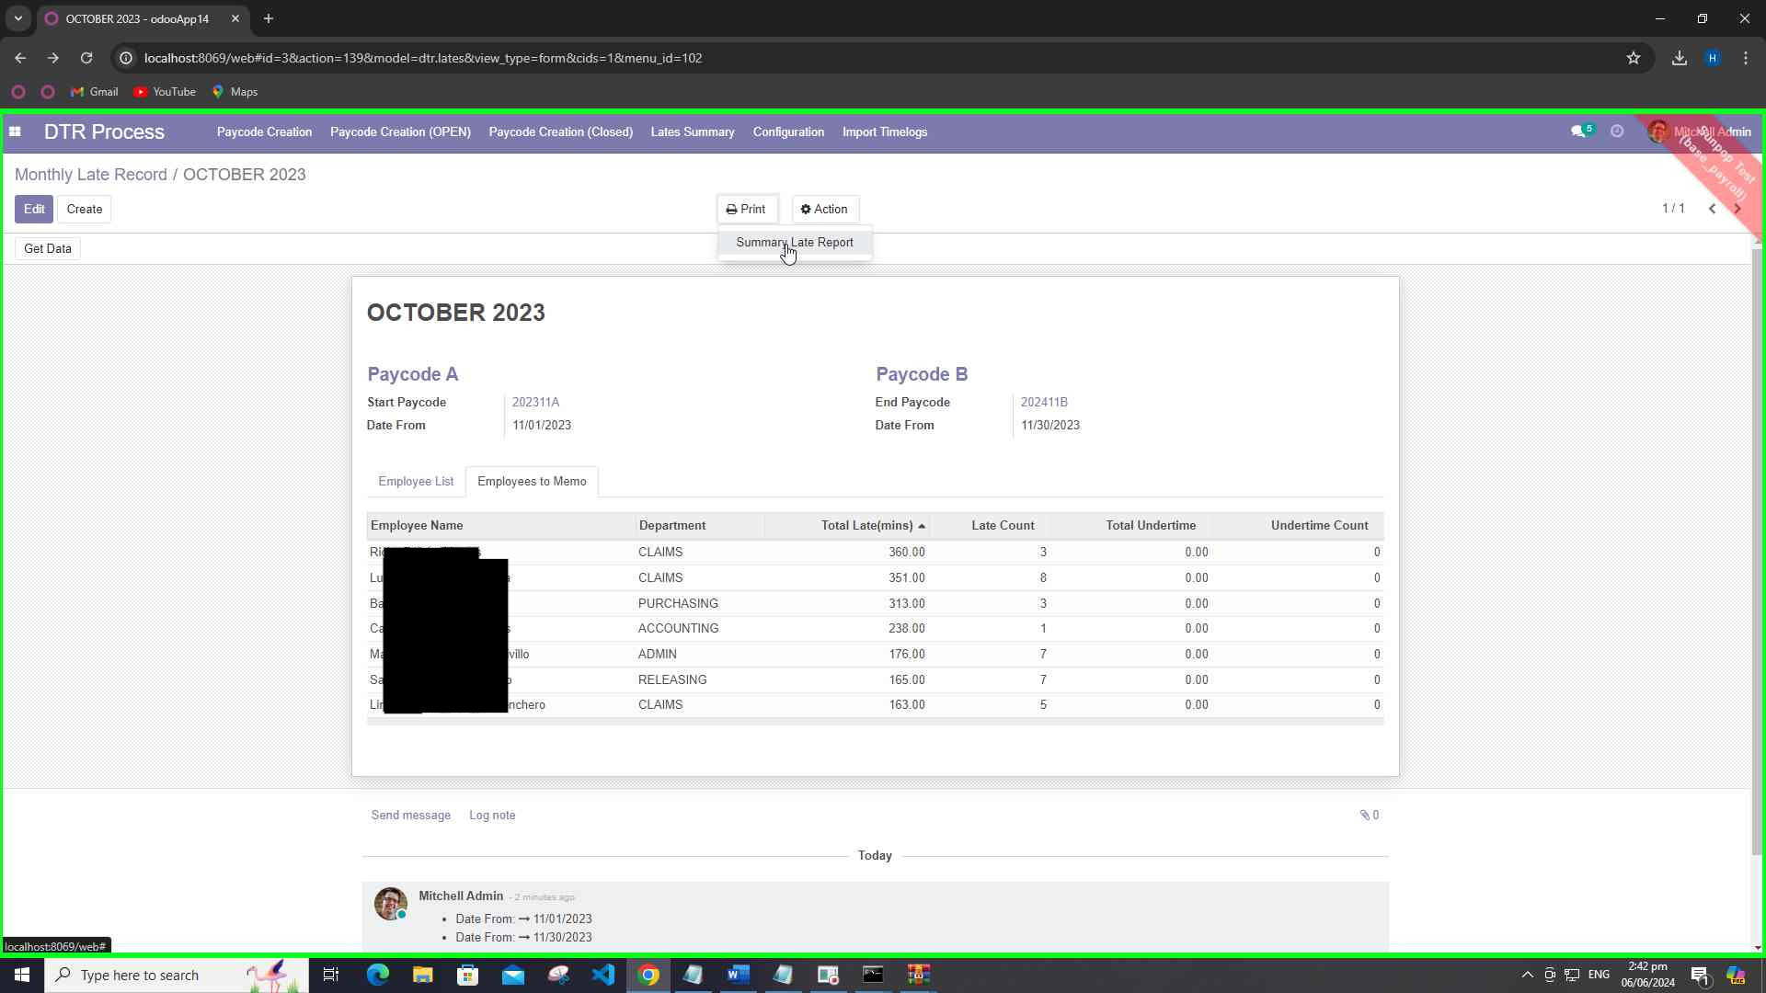 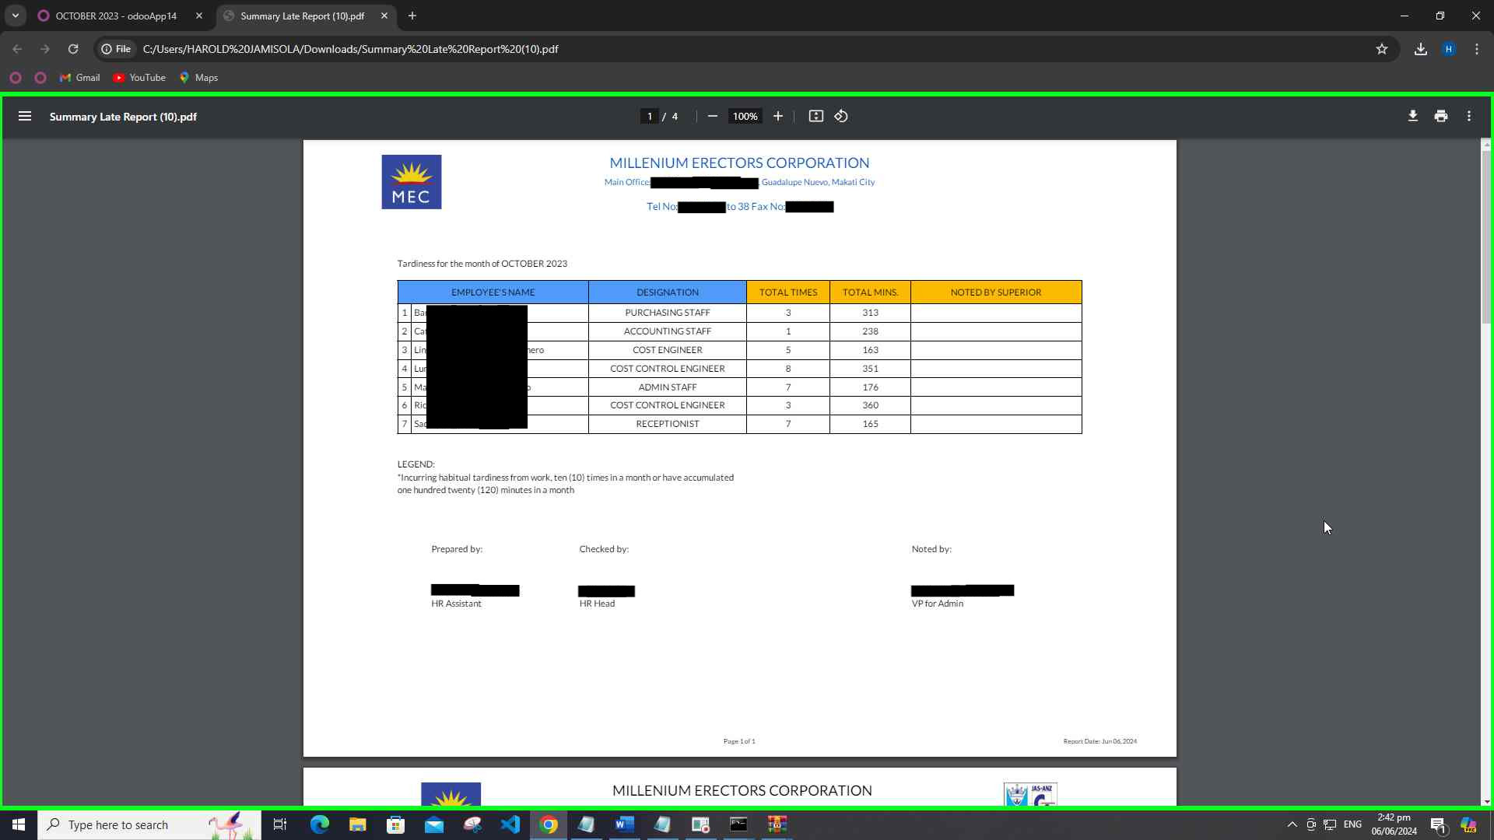 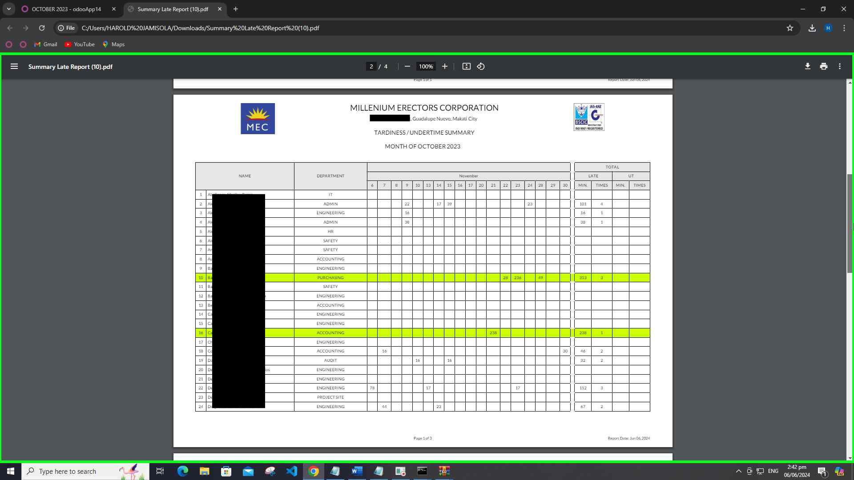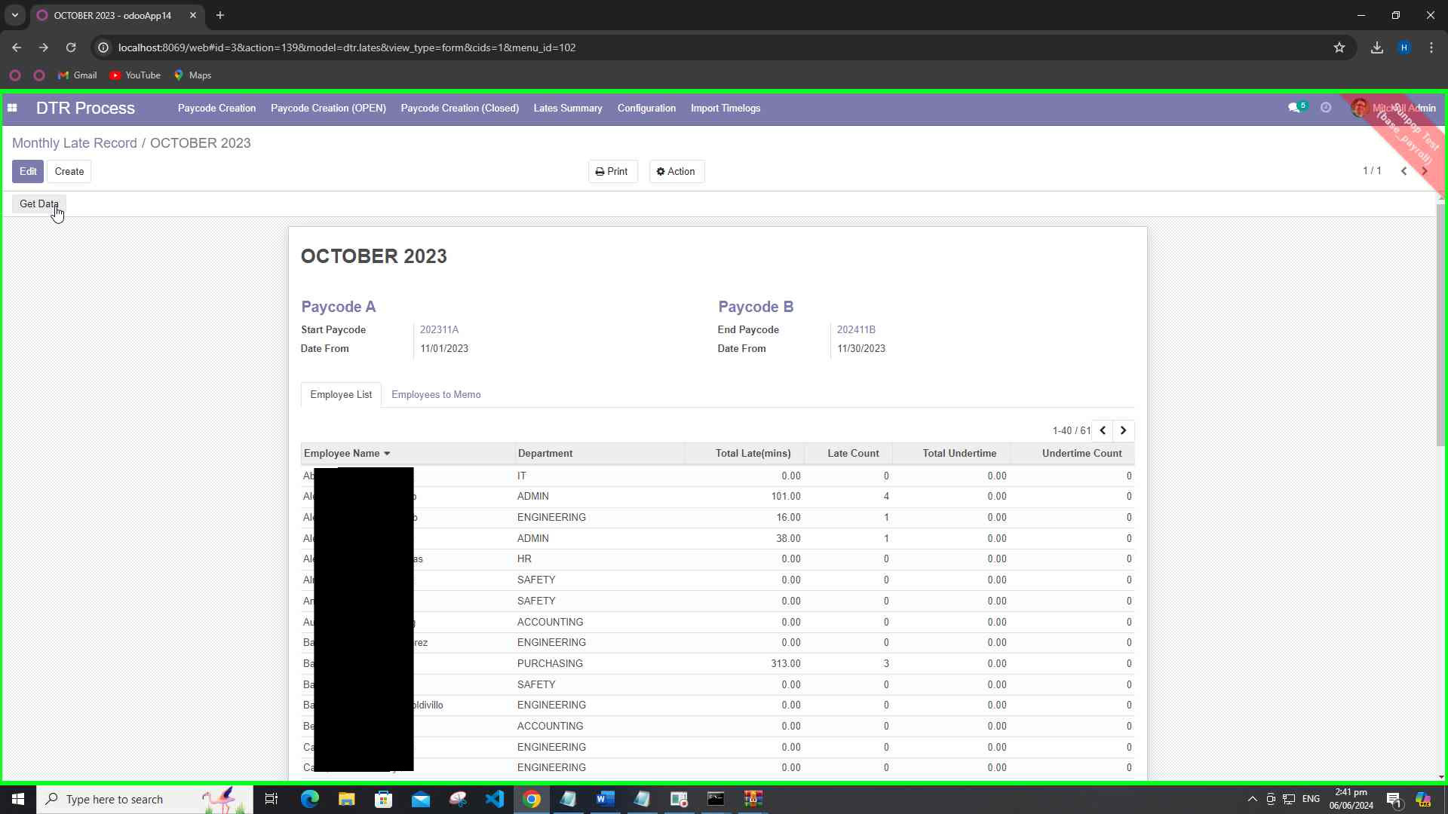

1. **Print Paycode Summary Report**
   * Generate and print the Paycode Summary Report.

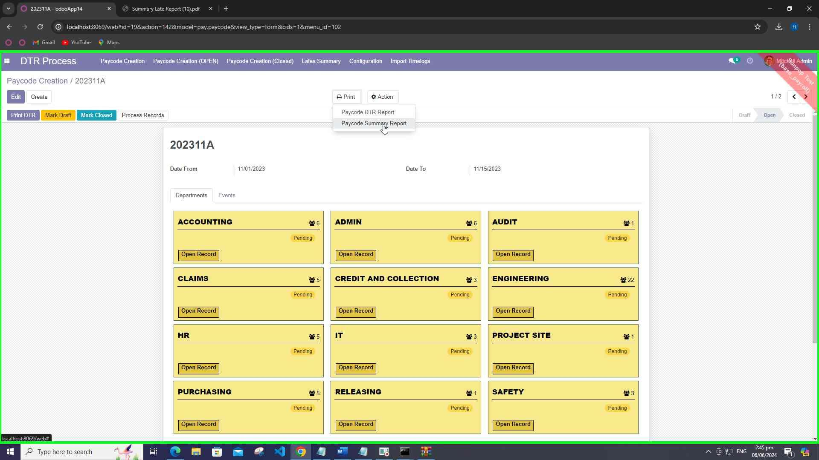

1. **Repeat Process**
   * Start again from creating a new paycode for the next pay period.